 | Weekly Insights | Nov 20, 2025
 | Item | Page
 | Stories of the Week | 1
 | Corn | 30
 | Wheat | 32
 | Soybeans | 34
 | Soybean Meal | 36
 | Soybean Oil | 38
 | Weekly Prices | 40

Executive Summary
Corn – Post-WASDE Balance Sheet Heavy on Paper, but Cash Still in Control
December corn ended the period at $4.35/bu, down one cent from last week, as the market digested a November WASDE that was bearish vs expectations but only a modest step away from September. USDA cut its assessment of the average US yield to 186.0 bu/acre (–0.7 bpa), trimmed production by about 60 mbu, and still pushed ending stocks up to 2.154 bbu (+44 mbu vs September), while raising exports by 100 mbu in line with stronger early-season demand. Weekly inspections surged to roughly 2.05 MMT for the week ending Nov 13, lifting 2025/26 cumulative inspections to about 15.83 MMT, over 70 percent above last year’s pace, with recent weeks more than doubling year-ago levels, and broadly consistent with a 3.075 bbu export program.
The nearby Dec–Mar spread tightened slightly from –14¢ to –13¢ (58 percent of full carry), reflecting firmer nearby demand from Gulf exporters and steady pull from ethanol plants even as overall supplies remain comfortable. Basis at the Gulf and key interior corridors held firm, and together with strong inspections, that physical strength continues to offset the heavier paper balance sheet.

Wheat – Bearish WASDE Stocks, but US Export Pace Refuses to Back Off
Wheat spent the week absorbing a clearly heavier November WASDE while leaning on a stronger-than-expected export pace. USDA lifted 2025/26 US production to 1.985 bbu (from 1.927 bbu in September) and ending stocks to 901 mbu (from 844 mbu), above pre-report expectations around 867–869 mbu. Globally, world production rose to 828.9 MMT (from 816.2 MMT) and world ending stocks to 271.4 MMT (from 264.06 MMT), reinforcing a looser wheat balance. Futures broke on report day, with December SRW sliding toward $5.27/bu, but recovered into the mid-$5.40s as weekly inspections of about 246.5k mt kept marketing-year shipments in the high-teens percent above last year and broadly aligned with USDA’s unchanged 900 mbu export projection.
The Dec–Mar SRW spread tightened slightly from –14¢ to –13¢ (roughly 56 percent of full carry), consistent with a market that recognizes heavier stocks on paper but is still seeing stable nearby pull from export channels. Gulf and PNW FOB indications showed only modest week-over-week moves even with Russian 12.5 percent FOB near the low-$230s/mt, so wheat remains a classic carry market, but one where the firmness of export execution continues to keep 901 mbu feeling more like a ceiling to probe than a surplus the market is being forced to clear.
Soybeans – WASDE Slightly Tighter Than Feared, Cash and China Flows Pull the Board Higher
Soybeans reversed their initial post-WASDE break and finished the period firmer, with January futures trading in the mid-$11.50s as cash and China flows outweighed USDA’s more cautious export stance. The November WASDE cut USDA’s estimate of the average US yield to 53.0 bu/acre (–0.5 bpa), reduced production to 4.253 bbu (–48 mbu vs September), and pulled total predicted 2025/26 supply down to 4.590 bbu, while exports were cut 50 mbu to 1.635 bbu, crush held at 2.55 bbu, and ending stocks set at 290 mbu, only about 10 mbu below September. World soybean ending stocks dipped 2.0 MMT to 121.99 MMT, and the board initially sold off on Friday before flipping higher on Monday as record NOPA October crush (227.65 mbu) and confirmation of fresh Chinese buying, including roughly 800,000 tonnes attributed to COFCO and 792,000 tonnes in USDA daily sales.
Weekly inspections around 1.18 MMT pushed season-to-date shipments to roughly 10.11 MMT (42 percent below last year). The Jan/Mar spread tightened from –14¢ to –7¢, roughly 31 percent of full carry, a clear sign that nearby pull from crushers and exporters improved despite USDA’s export cut. Gulf and processor basis stayed historically firm for harvest. The balance sheet is still not “tight” on paper, but crush, basis, and Chinese demand are doing enough to justify mid-$11s rather than a slide back to the low end of the recent range
(Carry % calculated assuming 7% annual interest and \$0.05/bu per month storage/insurance cost over the spread interval.)

Macro Mostly Neutral, China Trade Signals and South American Policy in Focus
Macro inputs were broadly neutral: the Dollar Index held near recent ranges and crude drifted below $60/bbl, softening biofuel margins but offering some freight relief. The BRL stayed defensive and the ARS weakened further in parallel markets, preserving strong selling incentives in Brazil and Argentina. Policy discussion remained centered on how much of China’s US soybean buying is state-reserve driven (and how binding the tariff really is in that context) and on Argentina’s evolving export-tax framework, which still represents a structural bearish risk for world prices if cuts become durable. (add the prices)
Weather – US Harvest Wraps, Central Brazil Sees Patchy Relief

As of November 16, USDA estimated that US corn and soybean harvest were 91 percent and 95 percent complete respectively, shifting attention to logistics, basis and export flow. In Brazil, central and northern regions continued planting at a normal pace, while parts of Rio Grande do Sul and Paraná saw intermittent delays and less-than-ideal moisture, keeping some early-season risk premium alive for soy and, indirectly, safrinha corn. In Argentina, improved soil moisture is supporting early corn and soybean establishment and wheat filling under mostly normal conditions. With USDA already assuming large South American crops, any persistent shift toward a drier pattern in key southern Brazilian states would quickly become a more active driver of spreads and flat price.
What’s Next (Nov 13 – Nov 19):
USDA Export Sales Catch-Up: Confirm how much of the recent Chinese soybean buying is on the books and whether corn and wheat commitments remain ahead of the pace required to meet USDA’s new-crop projections.
Brazil Weather Continuity: Ongoing dryness or hiccups in southern Brazil could tighten early-season supply expectations and support nearby soy/corn spreads.
River & Barge Logistics: Seasonal barge constraints into the US holiday period will be key for Gulf basis, especially soybeans.
Ethanol Production Trend: Next EIA update will test whether corn grind can hold up against weaker crude.
Russian FOB & Export Pace: Continued heavy Black Sea shipments at aggressive FOB levels should cap wheat rallies; any disruption would favor US HRW/SRW.
China Buying Pace: Given the unconfirmed verbal framework, any actual purchase volume or shipment timing (Q4 vs Q1) will be crucial for basis and board strength.
Table A – CME Futures (Front Contracts)
(Prices in USD per bushel, volume/open interest in contracts)
Contract (Front Month) | 11/12/2025 Close | 11/19/2025 Close | Change (Δ) | Δ% | 5-day Realized Vol* (x) | Open Interest Δ  (x)
Corn (Dec ’25) | $4.36 | $4.35 | -$0.01 | -0.23% | 5% (ann.) | -5k (est.)
Soybeans (Jan ’25) | $11.32 | $11.50 | +$0.18 | +1.59% | 8% (ann.) | +2k (est.)
Wheat (Dec ’25) | $5.34 | $5.46 | +$0.12 | +2.25% | 10% (ann.) | 1k (est.)
5-day realized volatility estimated from daily settlement price changes.
Actual contract open interest changes are estimated; total corn OI rose slightly as new-crop hedges built, while wheat OI fell with Sep contract deliveries.
Table B – Key Calendar Spreads & % of Full Carry
Spread (Crop ‘25→‘26) | 11/12  Quote | 11/19  Quote | Δ (carry) | % Full Carry* | Market Implication
Corn Dec–Mar | -$0.14 | -$0.13 | +0.01 | 58%
  Carry narrowed slightly but remains moderate; still a comfortable balance sheet with firm nearby demand from exporters/ethanol.
Soy Jan–Mar | -$0.14 | -$0.07 | +0.07 | 31% | Carry narrowed sharply as nearby strengthened on record crush and new China business; front end less relaxed than last week.
Wheat Dec–Mar | -$0.14 | -$0.13 | +0.01 | 56%
  Carry a touch tighter w/w but still a classic storage market; heavier WASDE stocks but no sign of front-end squeeze.
Assumes 7% annual interest + $0.05/bu/month storage/insurance. Full carry (3 months) ≈ $0.22–$0.23 for corn & SRW wheat; (2 months) ≈ $0.22 for soybeans. % of full carry = (calendar spread ÷ calculated full carry).
Table C – Notable International Futures (weekly moves, if significant):
Exchange (Front Month) | 11/12 USD Price | 11/19 USD Price | Δ% | Notes
Dalian Corn (Jan) | ¥2,151($6.46/bu) | ¥2,162($6.49/bu) | +0.5% | China corn futures held firm on steady feed demand; domestic prices remain well above import parity even after tariff rollback.
Dalian Soymeal (Jan) |  |  | -1.7% | Soymeal eased on sluggish hog margins, with steady inclusion rates but subdued feed demand.
  ¥3,046 ($429/mt)
  ¥2,994 ($421/mt)
B3 (São Paulo) Corn (Nov) |  |  | +5.4% | Real weakened sharply this week; local corn prices rose in BRL but still softened slightly in USD on steady domestic logistics and competitive US Gulf offers into MENA and Asia.
  R$64.20 ($11.75)
  R$67.88 ($12.38)
Euronext Wheat (Dec) |  |  | +0.8% | EU wheat held steady amid ample stocks; slight firmness capped by cheap Black Sea offers. Russian 12.5% FOB remained ~$232–233/mt.
  €196 ($223/mt)
  €197.5 ($225/mt)

Corn Market Deep Dive
Post-WASDE Reaction: The November WASDE reset the corn balance sheet in a way that was bearish relative to expectations but only modestly different from USDA’s September baseline. USDA cut the national corn yield to 186.0 bu/acre, a reduction of just 0.7 bpa from September’s 186.7 bpa, and above the pre-report consensus clustered around 184–185 bpa. Production was lowered by roughly 60 million bushels from the September estimate, but the crop remains historically large and materially above what analysts anticipated going into the report. USDA’s prediction of new-crop US ending stocks rose from September’s 2.110 billion bushels to roughly 2.154 billion, a 44 million bushel increase that landed slightly above the average trade estimate near 2.13 billion, this was enabled by a 207-million-bushel upward revision to USDA’s initial assessment of 2024/25 ending stocks from the September 30 Grain Stocks report, which more than offset the production cut and export hike. USDA also lifted its 2025/26 US export projections by 100 million bushels, aligning the forecast with the strong pace of early-season inspections and marking one of the few major demand-side adjustments between the two reports. Ethanol use, feed/residual, and other domestic categories were effectively unchanged from September.
Globally, USDA lowered its prediction of 2025/26 world ending stocks slightly versus September as well, reinforcing the broader theme of comfortable but not burdensome supply. The adjustment was minimal, from 281.4 MMT in September to 281.3 MMT in November, with reductions in China offset by small increases in Argentina, Mexico, and Ukraine. Taken together, the November update was less aggressive than analysts expected on US supply cuts, while global balances tightened only marginally, leaving the market in a recalibration mode rather than reacting to any major surprise
Futures & Spreads: Corn futures traded through a two-stage WASDE reaction: a sharp break on Friday to approximately $4.30/bu as the lighter-than-expected yield cut took bullish momentum out of the market, followed by a steady rebound early in the week to $4.35/bu as physical flows and basis strength reasserted themselves. December futures pushed lower immediately after the report, pressured by the realization that the market had positioned for a deeper production reduction. But the early-week recovery highlighted that the pullback lacked follow-through, with exporters and processors still bidding firmly enough to keep the front end supported. The nearby Dec/Mar structure narrowed slightly to roughly –13¢, about 58 percent of full carry, reinforcing a market that remains comfortably supplied and shows no need for inversion to ration demand. Post-WASDE commentary continued to frame the move as “bearish on paper, steadier in practice,” and nothing in the curve suggested meaningful stress or tightening beyond normal seasonal adjustments.
Funds & Positioning: With CFTC reporting still delayed, there is no reliable read on managed-money exposure around the November WASDE. What can be inferred from price behavior and options flow is that the report-day break followed by a steady early-week recovery was more consistent with short-term position clean-up than a shift in directional conviction. For now, positioning sits behind more observable signals, basis, inspections, and export execution, which remain the dominant drivers.
US Cash & Basis: The physical market continued to outpace futures this week. USDA reported 2.053 MMT of corn inspections for the week ending November 13, well above last week’s 1.484 MMT and keeping cumulative 2025/26 shipments near 15.84 MMT, more than 70 percent above last year’s pace. Cash tone reflected that strength: Gulf and interior basis held firm (Gulf CIF around +74¢ to +82¢ over December futures), supported by active export loading programs and improved river logistics. Ethanol demand remains steady, with weekly production still running at levels that keep processors bidding consistently even as crude softens. In short, the cash market remains the stabilizing force, firm enough to keep the front end supported even though futures continue to reflect a heavier paper balance sheet.

Export Flows: The long-delayed USDA Export Sales release helped clarify the backlog of commitments, showing net corn sales of approximately 1.9 MMT for the catch-up week ending September 25, with weekly exports at 1.32 MMT. As of that date, cumulative outstanding sales reached 16.55 MMT (up from 10.5 MMT last year), and accumulated exports stood at 4.99 MMT (versus 3.41 MMT previously). Sales data heavily favored soybeans in terms of headline flash activity, but corn maintained a strong underlying shipment program, with exports pacing well ahead of last year and trending comfortably toward the revised USDA export forecast of 3.075 bbu (about 78 MMT). With Gulf loadings leading the week and strong participation from Mexico (7.71 MMT in outstanding sales) and other Western Hemisphere buyers like Japan (1.96 MMT) and South Korea (1.42 MMT), the execution side of the export program has shifted from a concern to a source of support. The ability of shipments to continue at or above the pace implied by USDA’s target will remain a critical watchpoint heading into December.
International Trade: Global pricing continues to reflect a well-supplied world corn balance, with FOB indications across the US, Brazil, and Argentina clustered closely enough to keep trade flows sensitive to freight and timing rather than outright price advantage. US Gulf values remain competitive into Northern Hemisphere markets, while Brazil continues to dominate the Asian lanes thanks to freight efficiencies and still-ample internal supply. Argentina’s position has firmed slightly as planting progresses and weather remains broadly supportive. The modest delay in Brazilian soybean planting remains a secondary watchpoint, given its potential to push safrinha corn planting deeper into a less-favorable window for rainfall and growing conditions, but for now global fundamentals remain comfortable and consistent with USDA’s higher world ending-stocks figure. (add international prices)
So What? The post-WASDE corn narrative blends a heavy paper balance sheet with a surprisingly firm physical environment. USDA delivered a bearish adjustment relative to expectations, yield cut smaller than consensus, production still massive, and ending stocks higher, but the export and basis data continue to push back against a deeper price decline. Shipments are running well ahead of last year, the revised export forecast now aligns with actual flow, and processors remain active buyers. The next few weeks will determine whether the strength in inspections proves durable enough to offset the bearish supply tone, but for now corn is trading a tug-of-war between a heavy balance sheet and a physical pipeline that refuses to soften.

Soybean Market Deep Dive
Post-WASDE Assessment: The November WASDE landed slightly tighter than many in the trade feared, but the composition of the changes left soybeans feeling more “neutral with upside optionality” than outright bullish. USDA cut its assessment of the average US soybean yield to 53.0 bu/acre, down 0.5 bpa from September’s 53.5, trimming production to 4.253 billion bushels (–48 mbu vs September). USDA’s expectation for the 2025/26 US soybean supply now stands at 4.590 bbu, reflecting both the smaller crop and slightly lower beginning stocks than USDA carried in September. At the same time, USDA lowered its prediction of new-crop exports by 50 mbu to 1.635 bbu, left crush unchanged at a record 2.55 bbu, and pegged ending stocks at 290 mbu, down from roughly 300 mbu in September, implying a stocks-to-use ratio near 6.8 percent versus about 6.3 percent last year. Pre-report surveys had generally anticipated only a modest reduction in yield, little or no change to exports, and an increase in carryout from September levels rather than a decline, so the combination of slightly smaller supply and a lower ending-stocks figure was less bearish than some had positioned for. Globally, USDA trimmed world soybean ending stocks by 2.0 MMT to 121.99 MMT, a marginal adjustment that reinforces the message of adequate but not burdensome inventories.
Futures & Spreads: Soy futures traded the report in two acts. On Friday (Nov 14), January beans dropped about 22¢ to roughly $11.24/bu as the market focused on the export cut and viewed the WASDE as less bullish than hoped. That weakness was fully reversed early the following week: on Monday (Nov 17), Jan futures rallied nearly 33¢ and settled at $11.57/bu, aligning with firmer cash flows and renewed Chinese buying. By the end of the period, Jan beans were holding in the mid-$11.50s, up roughly 20–25¢ from pre-report levels. The nearby curve stayed in carry but not at full carry: the Jan/Mar spread traded near 7¢ by week’s end, down from –14¢ ahead of the report, a tightening to roughly 40 percent of full commercial carry. That narrowing is consistent with stronger nearby pull from crush and exports relative to the heavier, more comfortable balance sheet USDA outlined in September.
Products & Crush: Domestic crush remains the core bullish anchor. NOPA reported October crush at 227.65 mbu, the largest monthly crush on record, up about 13.9 percent year on year and roughly 15 percent above September, beating all trade estimates comfortably. Board crush margins were described as “historically strong” in early November, helped by firm soymeal values and only modest softness in soybean oil following weaker crude. Even after Monday’s futures rally, margins stayed well above the long-run historical average, supporting aggressive processor bids. USDA’s November WASDE kept 2025/26 crush unchanged at 2.55 bbu, effectively validating that plants will need to run hard to meet both feed and renewable diesel-linked oil demand. The combination of record realized crush and USDA’s refusal to trim that line item reinforces the idea that crush, not exports, is doing most of the heavy lifting on the demand side versus both the September balance sheet and pre-report analyst expectations.
Funds & Positioning: With CFTC data still catching up from earlier reporting disruptions, there is no reliable breakdown of speculative positioning around the November WASDE. What can be said from the tape is that the sequence of a sharp break on report day followed by an even stronger rally early in the week is consistent with short-term position clean-up and fresh discretionary buying rather than a one-off headline squeeze. Beyond that, any precise statements about fund net length or short-covering would be speculative, so for now positioning has to be treated as a secondary input behind more observable signals such as spreads, basis and crush margins.
Cash & Basis: Cash markets are telling a tighter story than the carryout alone. At the Gulf, CIF Nov soybean barges were quoted around +72¢ over Jan, with FOB export premiums for December near +107¢ over Jan, both historically firm for harvest. Tight nearby loading slots at Gulf and PNW terminals kept exporters competing for physical, with PNW values running 20–30¢/bu richer for some positions. Interior processors and river elevators leaned into the post-WASDE rally: spot basis gained 5¢ at major crush plants (Decatur, Lafayette) and 2–3¢ along the Mississippi River as end-users moved to secure beans in the face of record crush margins and the pickup in Chinese interest. Nationally, basis remains historically strong for harvest, especially at export gateways and crush hubs. The firmness in basis aligns with the tightening in the Jan/Mar spread from –14¢ to –7¢, signaling a stronger front-end pull than the balance sheet alone implies.
Trade Flows & International Competition: USDA’s catch-up export data and inspections confirm a decent but uneven export story. Weekly inspections totaled 1.125 MMT for the week ending November 6 and improved to 1.176 MMT for the week ending November 13, a slight w/w increase that keeps the early-season pace firm. Season-to-date inspections now stand near 10.11 MMT, roughly 42 percent below last year’s very slow start, though still trailing the five-year average for this point in the marketing year. On the sales side, delayed FAS reports showed about 0.33 MMT of Chinese purchases followed by just over 0.10 MMT of cancellations a reminder that commercial buying remains hesitant. Against that backdrop, the market reacted strongly to reports that COFCO booked around 14 US cargoes (0.85–0.90 MMT) for Dec/Jan shipment, while USDA’s daily system confirmed 792,000 tonnes in fresh sales to China. Outside China, Mexico, the EU, and Egypt remained steady buyers. Even so, USDA’s 1.635 bbu export forecast reflects a cautious stance versus September, and the extent to which China executes additional reserve-oriented purchases will determine whether that export line proves conservative or needs trimming later in the marketing year.
Policy Context: A key discussion this week is who in China is absorbing US soybeans. If state reserves rather than crushers are driving the recent buying, the 10 percent tariff becomes far less restrictive, a duty paid by the government and returned to the same government changes the effective cost. That helps explain how China could lift US cargoes at a nominal premium to Brazil without signaling an improvement in crush margins. Reserve demand supports US export volumes, but it does not imply stronger near-term industrial use. The commercial import picture remains tied to margins, feed demand, and Brazil’s relative discount.
So What? Taken together, the November WASDE and subsequent data leave soybeans in a finely balanced but higher-priced environment. Versus September, USDA acknowledged a slightly smaller US crop and tighter global stocks but offset most of that with a 50 mbu export cut, leaving carryout only 10 mbu lower and still firmly in “adequate but not burdensome” territory. Versus analyst expectations, the key surprise was that ending stocks fell instead of rising, which is why the initial bearish knee-jerk on Friday gave way to a stronger rally once traders focused on record crush and fresh Chinese buying. Structure matches that shift: spreads narrowed to about 31 percent of full carry, basis is historically strong at the Gulf and at major crush plants, and futures are holding in the mid-$11s rather than slipping toward $11. The risk skew from here is dominated by China and South American weather. If COFCO’s recent 0.9 MMT purchase proves to be the first leg of a larger execution against the 12 MMT pledge, USDA’s 1.635 bbu export projection and 290 mbu carryout could prove conservative. If instead Chinese buying fades and South America delivers large crops, the export line may need to move lower again. For now, crush and cash remain the heavy lifters, and the board is willing to pay mid-$11s for that uncertainty.

Wheat Market Deep Dive
Post-WASDE Assessment: The November WASDE confirmed that wheat is carrying the heaviest balance sheet of the major US row crops and did so in a way that was clearly more bearish than the market had discounted. USDA increased its assessment of 2025/26 US wheat production from 1,927 mbu in September to 1,985 mbu in November, driven by a higher harvested area of 37.2.million acres (from 36.6 million acres) and a yield bump from 52.7 to 53.3 bu/acre. Total supply rose from 2,898 to 2,955 mbu, while domestic use and exports were left unchanged at 1,154 mbu and 900 mbu respectively, meaning virtually the entire supply gain was pushed straight into ending stocks. Carryout moved from 844 mbu in September to 901 mbu in November, a six-year high and above pre-report expectations that clustered around 867–869 mbu.
On the world side, USDA raised 2025/26 wheat production from 816.2 to 828.9 MMT and ending stocks from 264.1 to 271.4 MMT, again overshooting the median survey which had world stocks closer to 266 MMT. In other words, the trade was already braced for a heavier wheat story, but USDA still managed to come in meaningfully above consensus on both US and world stocks. The first reaction on Friday was a “headline-bearish” selloff, but as traders and analysts looked deeper into the data, the market began to lean more heavily on strong export flows and resilient FOB pricing to decide whether 901 mbu is a ceiling or a stepping-stone.
Futures & Spreads: Outright price action reflected the two-step WASDE reaction noted in corn and soybean markets. On report day (Friday, Nov 14), December SRW wheat slid to about $5.27/bu, a two-week low, as traders absorbed heavier US and global ending stocks and followed corn and soy lower. By Monday, Nov 17, futures had fully stabilized: December SRW recovered to $5.44/bu, up roughly three percent from Friday’s close, aligning with firmer export signals and steady FOB values. December HRW held near $5.29/bu, while December Euronext wheat settled around €190/mt. Spreads saw limited reaction: the Dec/Mar SRW spread traded near, 13¢, which is roughly 56 percent of full commercial carry, consistent with a market that recognizes comfortable supply but sees no sign of pipeline stress. With carry now wider than in early November and expectations for new-crop US carryout clearly above USDA’s September predictions and analyst expectations, the curve continues to reward storage rather than suggesting nearby tightness.
Global Supply & Demand: The global side of the wheat story was just as important as the US changes. The November WASDE lifted world wheat production by about 12.7 MMT versus September (from 816.2 to 828.9 MMT) and world ending stocks by roughly 7.4 MMT (from 264.1 to 271.4 MMT), a two percent increase that pushes global inventories further away from any “tight” narrative. The bulk of those upward revisions came from key exporters: USDA raised Russian production to around 86.5 MMT with exports at 44 MMT, while also nudging up Argentina and Australia. That picture is being confirmed in real time. SovEcon and APK-Inform report that Russia shipped about 2.0 MMT of wheat in the first ten days of November, roughly eight percent above the same period last year, reinforcing Russia’s role as the dominant marginal supplier. Russian 12.5 percent protein FOB values are holding near $233/mt, still cheap enough to anchor world milling wheat prices. Euronext around €190/mt keeps EU wheat competitive in some Mediterranean and North African routes but not cheap enough to displace Russia across the board. Compared with September, the message from USDA plus the trade is straightforward: the world wheat balance is looser, exporters have more to move, and Russia continues to set the floor.
Cash & Basis: US cash signals remain softer than corn and soybeans but not nearly as bearish as the WASDE headline suggests. USDA reported 246,533 mt of wheat inspected for shipment during the week ending Nov 13, down from 291,443 mt the prior week but still above the 197,138 mt inspected in the same week last year. Marketing-year-to-date inspections now total 12.35 MMT, compared with 10.35 MMT last year, leaving shipments running about 19 percent ahead of last season, fully consistent with USDA’s 900 mbu export projection. FOB indications from US Wheat Associates showed only modest w/w changes across Gulf SRW, HRW and PNW classes, and there is still no evidence of panic discounting despite Russian 12.5 percent protein FOB levels near the low-$230s/mt. With the board still in comfortable carry (–13¢, 56 percent of full carry) and exporters continuing to execute steady programs, domestic basis appears stable enough to absorb the heavier stock number the WASDE introduced.
Trade Flows: The latest flows reinforce a picture that is more constructive than the WASDE stocks alone imply. USDA’s November projection for 2025/26 US wheat exports remains 900 mbu, roughly nine percent above last year. The long-delayed USDA Export Sales release helped clarify the backlog of commitments, reporting net wheat sales of 540 TMT for the catch-up week ending September 25, with weekly shipments of 739 TMT. As of that date, cumulative exports stood at 9.54 MMT versus 8.28 MMT at the same point a year earlier, roughly 15 percent ahead of last year’s pace. Russia and Ukraine continue to ship aggressively via Black Sea and Danube routes, capping US upside, but the fact that US volumes continue expanding year-on-year in that competitive environment underscores that the 900 mbu export line remains very much achievable. Inspections through mid-November have since pushed cumulative shipments to 12.36 MMT, now running nearly 19% ahead of last season. If this execution holds through the first quarter, USDA may ultimately need to acknowledge a stronger shipment program , even with the larger domestic crop, when it revisits the balance sheet in coming months.

Speculative Positioning: On the positioning side, the post-WASDE action looked more like routine position-cleaning than the start of a new trend. With CFTC reports still delayed, there’s no solid read on managed-money exposure, and intraday exchange data isn’t enough to pinpoint who was driving the moves. What we can say is that the report-day sell-off and the early-week bounce happened on active volume, consistent with traders adjusting hedges after a major release. Beyond that, wheat doesn’t look heavily one-sided: commercials are well covered, and the curve continues to reward storage rather than reflect any extreme speculative build
So What? The wheat setup after the November WASDE is the same case of bearish paper stocks running into a less-bearish physical reality experienced across row-crop markets. USDA lifted its prediction of 2025/26 US ending stocks from 844 mbu in September to 901 mbu in November and raised world stocks from 264 MMT to 271 MMT, decisively overshooting analyst expectations. That justified the initial break toward $5.27/bu, but the quick recovery back into the mid-$5.40s, the stability in FOB values, and shipments running 19 percent ahead of last year argue that the market is not trading wheat as a surplus that needs to be cleared aggressively. The Dec/Mar SRW spread around –13¢ (56 percent of full carry) reinforces that storage economics, not nearby tightness, remain the dominant structure. For commercials, wheat is still a hedge-selling and carry-capture market rather than a scarcity-premium market. Rallies into the high-$5s will likely attract producer and exporter selling as long as Russian FOB values hold near the low-$230s/mt and world stocks remain elevated. The main upside risk would be a scenario where US exports continue outperforming while Black Sea shipments stumble, a combination that could tighten spreads even in a high-stocks environment. For now, though, storage, carry and Russia still anchor the market.

US Cash Market & Basis
Corn: Cash corn continued to run ahead of the board. Export inspections hit 2.053 MMT for the week ending Nov 13 (up from 1.484 MMT), pushing 2025/26 cumulative shipments to about 15.84 MMT, more than 70 percent above last year. Gulf exporters stayed active and CIF corn basis was reported steady to slightly firmer (around +74¢ to +82¢ over December futures) versus last week as barge logistics on the Lower Mississippi remained favorable. Interior bids in key river and ethanol corridors held their ground, firming fractionally in some spots—with plants still running hard enough to keep a consistent pull-on nearby bushel even as flat price softened. Nationally, basis is described as “firm for post-harvest” (national average around -37¢ under December), with only minor weakness in surplus Western Corn Belt locations where on-farm selling picked up on the early-week rally.
Soybeans: Soybean cash signals were the tightest of the three markets. At the Gulf, CIF Nov barges around +72¢ over Jan and FOB Dec premiums near +107¢ held at historically strong harvest levels, while PNW slots traded roughly 20–30¢/bu richer than the Gulf for some nearby positions. In the interior, crushers and river elevators leaned into the rally: spot bids gained about 5¢ at major plants such as Decatur and Lafayette and 2–3¢ along the Mississippi River as record NOPA October crush and fresh Chinese business encouraged end-users to extend coverage. With weekly inspections near 1.18 MMT and season-to-date volumes about 42 percent below last year’s slow start, the basis picture is fully consistent with the narrowing Jan/Mar spread and a market where physical demand is tighter than the paper carryout alone suggests.
Wheat: Wheat basis remained softer than corn and soy but still respectable given the heavier WASDE stocks. Export inspections of 246,533 mt kept marketing-year shipments roughly 19 percent ahead of last season, and Gulf/PNW FOB indications for SRW, HRW and soft white moved only modestly week-on-week despite Russian 12.5 percent FOB values stuck in the low-$230s/mt. Gulf SRW stayed discounted to HRW/HRS, but there was no sign of panic discounting after the report. Interior basis in the Southern Plains milling market remains defensive, reflecting carry incentives and comfortable supplies, but has not weakened enough to contradict USDA’s 900 mbu export projection. Overall, wheat cash markets are behaving like a classic carry environment: exporters and mills are willing to validate current board levels, but rallies into the high-$5s are still expected to draw hedge selling rather than chase nearby supply.

International Cash & Trade Flows
Brazil: Brazil continues to assert its dominance as the global supplier of both soybeans and corn. The ANEC now projects soybean exports in November at around 4.71 MMT, up from an earlier 4.26 MMT estimate. Corn export forecasts were also raised to approximately 6.36 MMT. On the pricing front, FOB Santos soybean offers remain strong (near $480/MT or $10.92/bu) and continue to hold a premium advantage over US Gulf equivalents into China. Although precise current FOB maize values are less clearly documented in the latest update, previous summaries had Brazil’s corn FOB offers around $210/MT ($5.30/bu) into Southeast Asia. Interior conditions show planting for the next soybean crop advancing (for example Mato Grosso is past the midway mark), but subsoil moisture deficits are still flagged in parts of Goiás and Tocantins. Export corridors remain functional with no significant congestion reported.
Argentina: Up-River FOB export prices in Argentina are reportedly steady to modestly lower: corn is offered near $205/MT, and soymeal (47 percent protein) around $305/MT, both broadly in line with recent levels. Farmer selling continues to slow after the end of the export incentive program, making upstream liquidity less aggressive. The Rosario Exchange reaffirmed its corn planting estimate at about 40 percent of area complete, above average, and reiterated an outlook of near 52 MMT production under neutral/wet summer conditions. The parallel-rate peso exchange (near ARS 1,410/USD) maintains pressure on local exporters and farm selling behavior. Wheat harvest is underway in the north under dry-but-manageable conditions with expectations near 24.5 MMT.
China: Import activity remains heavily Brazil-centric. US Gulf soybean offers (reported near +$2.20/bu over Jan futures) remain uncompetitive relative to Brazilian cargoes (roughly +$2.10/bu equivalent), which is contributing to Chinese bookings favoring Brazil. No new confirmed US soybean purchases by Chinese importers have been formally published through Nov 19 beyond the mid-month COFCO activity, and USDA did not report any new flash sales this week. The Nov 10 suspension of Chinese retaliatory tariffs on US corn and wheat (soybeans unchanged at 13 percent MFN duty) is noted but has not yet led to a major shift in Chinese buying patterns. On the domestic front, Dalian Jan corn futures topped ¥2,151/MT ($6.46/bu equivalent), still well above landed import parity, so commercial crush margins remain constrained. While market commentary around long-term Chinese soybean import targets (12 MMT for 2025, 25+ MMT through 2028) continues to circulate, these remain guidance rather than definitive purchase commitments.
EU / Black Sea: Russian 12.5% protein FOB wheat offers remain around $232/MT, reflecting export tax adjustments and sustained pricing discipline. Russia continues to win major tenders in Egypt and the Middle East. French wheat offered near $225/MT remains less competitive, especially as Maghreb and North African tenders favour Black Sea origin. Ukrainian corn continues steady flows via the Danube and rail with inbound FOB offers near ~$207/MT into Spain/Italy. Within the EU, internal grain availability has improved post-harvest, lessening near-term import urgency. Black Sea soymeal, Russian and Ukrainian origin, continues to displace U.S. product into southern Europe, aided by favorable freight and FX dynamics.
Other Origins: No major changes reported from Canada or South Africa. Canada’s spring wheat exports remain stable, targeting Mexico and East Asia. Australia’s harvest expansion across Queensland and New South Wales reveals improved protein but mixed yield outcomes after a dry winter. India remains effectively inactive on the global grain-export stage with no new policy shifts announced.
So What? US exporters continue to face structural headwinds in key Asian and MENA markets as Brazil and Russia maintain pricing leadership. China’s continued preference for Brazilian beans, even following tariff adjustments, limits US Gulf traction. While Argentina’s political calendar introduces a potential variable, it is not currently shifting the broader flow dynamic. Until FOB spreads narrow or tariff dynamics change materially, US cash and export strength will remain more reliant on domestic demand fundamentals and CIF competitiveness rather than on major export arbitrage gains.
Key Fundamentals & Reports (Nov 13 – Nov 19)
Government Data & Reporting: USDA reporting has fully normalized after earlier delays, with Export Inspections, Export Sales, and the November WASDE all published on schedule. The return of full data flow removed the uncertainty that shaped trading earlier in the month, particularly in soybeans where Chinese activity had been difficult to confirm. Crop Progress was not updated this week given harvest completion, leaving the market to rely on state updates and private surveys for any final fieldwork commentary. CFTC Commitments of Traders remain delayed, keeping speculative exposure opaque and pushing traders to lean more heavily on observable physical indicators, spreads, basis, export flow, rather than fund positioning as a directional input
Crop Progress: The late-season fieldwork is essentially finished, with corn 91 percent harvested and soybeans 95 percent complete, both slightly behind the five-year average. Winter wheat planting has reached 92 percent nationwide and emergence stands at 79 percent, each a few points below average, with most Northwestern states fully planted while Nebraska remains notably behind normal. Early HRW ratings show 45 percent of the crop in good-to-excellent condition, down from a year ago, and dryness in western Kansas and Oklahoma continues to be a point of attention as the crop moves toward dormancy.
Export Inspections (USDA FGIS – week ending Oct Nov 13): Corn inspections surged to 2.053 MMT (+38 percent w/w), pushing cumulative 2025/26 shipments to roughly 15.84 MMT, more than 70 percent ahead of last year and now firmly aligned with USDA’s higher 2.3 bbu export projection. Soybean loadings improved to 1.176 MMT, maintaining season-to-date shipments near 10.11 MMT, around 42 percent below last year’s exceptionally slow start. Wheat inspections totaled 246.5k tonnes (–15 percent w/w), but cumulative exports reached 12.35 MMT, nearly 19 percent ahead of last year and consistent with USDA’s unchanged 900 mbu target. The week’s flow reaffirmed a strong corn export program, a still-improving soybean pace driven by China, and a wheat program outperforming expectations despite global competition.
Export Sales (USDA FAS, catch-up releases): Delayed weekly sales reports finally caught up this week, delivering clarity after an extended period of backlog and quiet headlines. For soybeans, the data revealed net Chinese purchases of roughly 0.33 MMT offset by 0.10 MMT in cancellations, complemented by a separate USDA daily flash of 0.792 MMT in fresh sales to China, widely linked to state-owned COFCO securing at least 14 cargoes (0.85–0.90 MMT) for December/January shipment. Corn commitments held steady with strong participation from Mexico and other Western Hemisphere buyers, while wheat bookings proved sufficient to underpin USDA’s unchanged export line. The resolution of these delayed figures removed a key source of uncertainty that had constrained trader conviction earlier in November, helping support the firmer tone observed in nearby soybean and corn spreads.
Ethanol Production & Stocks (EIA – week ending Nov 7): Ethanol production held firm through early November, with the latest EIA print showing output at 1.075 mb/d for the week ending Nov. 7, consistent with the strong run rates seen through October (1.071–1.123 mb/d). Margins have softened alongside crude slipping below $60/bbl, but they remain positive enough to keep Western Corn Belt processor bids well-supported and maintain a steady grind. Stocks edged slightly higher, reflecting normal pre–year-end seasonal patterning rather than a demand slowdown. Overall, industrial use remains stable, reinforcing the firmness seen in nearby corn spreads and cash markets.
NOPA Crush: NOPA reported October crush at 227.65 mbu, the largest monthly crush on record and nearly 14 percent above last year. This confirmed that US processors are running hard into year-end and fully validated USDA’s 2.31 bbu 2025/26 crush projection. Strong soymeal demand and historically elevated crush margins continue to anchor domestic soybean usage, offsetting the softer tone in export forecasts.
CFTC Commitments of Traders: No new CFTC reports were released this week, leaving managed-money positioning entirely dependent on private trackers and CME open interest changes. Private estimates suggested only modest net changes: corn lightly net short with limited short-covering, soybeans biased toward modest net length after early-week buying, and wheat remaining heavily net short but with little confirmed movement. Without official data, speculative influence remains secondary to physical flows, basis strength, and the post-WASDE adjustment process.
So What? With USDA reporting fully restored and WASDE adjustments absorbed, market direction this week was driven overwhelmingly by physical movement rather than paper balance sheets. Corn fundamentals strengthened meaningfully on the back of another week of strong inspections and firm basis. Soybeans gained support from confirmed Chinese buying and record crush, easing concerns about the export cut in the WASDE. Wheat continues to carry the heaviest balance sheet but is outperforming expectations thanks to solid export execution and stable FOB values. With CFTC data still absent and South American weather moving into a more sensitive phase, the physical side of the market remains the primary anchor, and this week’s physical signals were decisively stronger than the headline supply numbers alone would suggest.

International Reports:
Brazil – ANEC Lineups & Diverging Weather: Mid-November ANEC schedules point to soybean exports near 4.71 MMT for the month to date and corn loadings around 6.3 MMT, consistent with strong second-crop movement but softer relative to historical volumes than October’s unusually heavy flow. Brazilian FOB values remain competitive: Santos soybeans traded near $480/MT ($10.90/bu), keeping a modest discount to US Gulf offers, while corn around $210/MT ($5.30/bu) continues to set the floor for global feed grain markets. Planting progress stayed split north–south: Mato Grosso maintained a near-normal pace while Rio Grande do Sul and Paraná showed patchier emergence due to intermittent dryness, a pattern that keeps some early-season risk premium alive. Central and northern regions received more regular rainfall, supporting replanting decisions and stabilizing forward yield expectations. No new CONAB revisions were released within the window, but private consultants continue to flag a slight downward bias to early soybean yield assumptions if southern rainfall remains inconsistent. Port logistics at Santos and Paranaguá remained fluid, with no reports of congestion.
Argentina – BCBA & MAGyP Updates: The Buenos Aires Grain Exchange reported corn planting advancing steadily under improved soil moisture, while soybean planting gained momentum across core provinces. Wheat harvest progressed in the northern belt, and BCBA raised production expectations to 24.5 MMT, broadly aligned with early-November assessments. Up-River FOB offers held steady, with corn quoted near $205/MT and soymeal around $305/MT, reflecting stable export competitiveness. MAGyP’s weekly updates showed no major surprises in sowing progress or crop conditions. The peso continued to weaken in parallel markets, sustaining strong export incentives, while farmer selling remained cautious ahead of ongoing political and macro uncertainty. Crushers continued to draw on inventories accumulated under September’s “soy dollar 5” program, keeping meal and oil flows steady.
China – Import Behavior & Post-Tariff Dynamics: China’s import behavior this week centered on confirmation of reserve-oriented US soybean buying, rather than commercial crush demand. Reuters reported COFCO securing 14 US cargoes (0.85–0.90 MMT) for Dec/Jan shipment, and USDA daily data confirmed 0.792 MMT of fresh sales to China. Despite this pickup, crushers remained focused on Brazilian offers for January–March arrival windows, and domestic margins stayed under pressure from high port inventories and weak soymeal demand. Chinese futures markets were broadly steady: Dalian corn hovered near ¥2,150/MT, soybeans around ¥4,970/MT, and soymeal near ¥3,040/MT, signaling muted domestic pull. No new announcements were made by MARA or Customs, and while China’s earlier tariff adjustments on US grains reshaped sentiment, soybean duties remain effectively unchanged for commercial buyers. Market chatter continued around whether state purchases dilute the tariff constraint, but operationally there was still no shift in crushers’ import behavior.
Black Sea / EU – Russia Maintains Competitive Edge: Black Sea origins maintained their grip on global pricing and tender activity this week. Russian 12.5% protein wheat FOB offers stayed firm in the $232–233/MT range, continuing to set the floor for milling wheat values worldwide and capturing the lion's share of Egyptian and Middle Eastern tenders. Russia's export tempo held strong, with early-November volumes tracking comfortably above last year's levels. Ukrainian corn flows via Danube and Black Sea ports remained competitively priced near $207/MT, keeping downward pressure on EU feed grain values. In Europe, winter wheat establishment progressed solidly across key areas, with FranceAgriMer reporting conditions steady in the mid-to-upper 60s percent good-to-excellent. EU internal supply feels comfortable, reflected in Rouen offers around $225/MT with little upward tension. No meaningful logistical issues were noted along Black Sea or Danube routes during the period.
Global – Multilateral Updates: No major new multilateral updates were released within the window, leaving IGC’s late-October numbers as the reference point. Global trade sentiment remained balanced: comfortable inventories for wheat and corn, record US crush supporting soy product markets, and early-season risk resting primarily in southern Brazil’s rainfall profile rather than geopolitical shocks. Freight, container availability, and shipping routes remained stable, keeping global arbitrage dominated by export competition rather than supply scarcity.
So What? Global grain flows continue to be shaped by Brazil’s dominance in corn, state-led Chinese soybean demand, and ultra-competitive Russian wheat pricing. Argentina remains competitively positioned but macro-risk sensitive, while Chinese importer’s buying pattern reinforced that US soy strength is being driven by reserves, not commercial crush margins. With no major multilateral revisions and logistics functioning smoothly, international markets continue to price off competitive origins rather than tightness. The next meaningful drivers will be Brazil’s late-November rainfall distribution and whether China converts this week’s reserve buying into sustained forward demand, both of which will influence nearby US spreads and basis as we move toward December.

Weather & Crop Conditions
United States
Crop Progress & Rainfall: US harvest is now essentially wrapped up, with corn 91 percent complete and soybeans 95 percent harvested, leaving only light activity in pockets of the Upper Midwest and far northern areas. Early-week precipitation across the Ohio Valley and Mid-South improved surface moisture and aided barge drafts along the lower Mississippi, helping normalize flow after recent low-water constraints. In the Plains, winter wheat establishment is progressing but remains uneven: planting has reached 92 percent and emergence stands at 79 percent, both slightly behind average, while persistent topsoil dryness across western Kansas and Oklahoma continues to limit early HRW condition gains despite scattered 10–20 mm showers.
River Levels & Logistics: Mississippi River conditions continued to stabilize, with gauge readings at Memphis, St. Louis and Baton Rouge improving modestly on the back of early-November rainfall. Standard barge drafts remained in effect through most of the week, keeping freight steady to slightly firmer depending on loading window and segment. Logistics along the Lower Miss and Ohio Rivers were described as “functional but still sensitive,” with carriers noting that water levels remain below historical averages, maintaining a cautious tone for the next 2–3 weeks of holiday-season traffic. Improved flow supported steady CIF basis levels and helped clear the large export inspection volumes reported this week.
Temperatures: Conditions stayed seasonally mild across much of the Midwest and Plains, with highs in the 50s–60s°F and above-normal warmth persisting into the weekend. The mild pattern aided final fieldwork and natural dry-down while slowing soil moisture recharge across the HRW belt. No frost events or quality concerns were reported, and the absence of severe cold continues to support winter wheat establishment in the central and northern Plains.
Outlook (6–10 days): NOAA’s mid-November outlook points to above-normal temperatures across the central US and continued dryness for Kansas, Nebraska and western Oklahoma. Improved rainfall chances are focused on the Ohio Valley and Lower Mississippi basin, providing potential incremental relief for barge logistics. For wheat areas, however, the forecast remains marginal, with limited precipitation expected to address deeper topsoil deficits across the southwestern Plains.
South America:
Brazil: Weather remained sharply divided between north–central Brazil and the southern belt. Regular showers returned across Mato Grosso, Goiás and Tocantins, delivering 20–50 mm in several producing areas and allowing soybean planting to recover momentum after early-season delays. Planting progress in the Central-West moved closer to normal historical pace, and replanting where necessary has proceeded smoothly. Subsoil moisture, however, remains below average across pockets of Goiás and northeastern Mato Grosso, keeping agronomic risks elevated until more consistent rainfall arrives. In contrast, southern states (Rio Grande do Sul and Paraná) continued to face patchier rainfall and uneven emergence, a theme closely watched by the trade given its potential influence on early yield expectations and safrinha planting windows. Forecasts from INMET and NOAA call for additional rainfall in the Central-West but limited relief for the southern belt over the next 7–10 days.
Argentina: Conditions remained broadly favorable. BCBA maintained adequate-to-optimal soil moisture ratings across most Pampas provinces, with only isolated dryness in southwestern Córdoba. Early corn and newly sown soybeans continue to establish well, supported by stable temperatures and periodic thunderstorms delivering about an inch (20–35 mm) of rainfall across central and northern regions. Wheat harvest advanced in northern provinces under benign conditions, and quality concerns remain limited. Near-term forecasts continue to point toward intermittent showers and moderate temperatures, sustaining an overall constructive outlook.
Global: Winter wheat development across the Northern Hemisphere continued on a generally steady track. In Russia and Ukraine, mild temperatures combined with adequate moisture supported solid emergence and early tillering stages. European conditions remained stable, with sufficient rainfall reported in France, Germany, and Poland; FranceAgriMer maintained ratings for French soft wheat in the upper 60s percent good-to-excellent. Down under, Australia's crop showed its typical regional divide: persistent dryness in Western Australia capped yield potential, whereas scattered showers in New South Wales and Queensland helped preserve harvest quality without dramatically altering overall output. Elsewhere, including India, South Africa, and Canada, no notable disruptions emerged during the period.

So What? With U.S. harvest now in the final stages (corn 91 percent complete, soybeans 95 percent), weather has largely faded as a domestic price driver, giving way to logistics and export execution as the key influences. Better barge movement along the river system has bolstered CIF basis levels and facilitated the clearance of robust corn and soybean inspection volumes. On the global front, Brazil continues to dominate the weather watch: steady rains have firmed up prospects in the Central-West, but patchy distribution in the south keeps a modest risk premium intact for soybeans, and by extension, early safrinha corn. Argentina's favorable pattern and rapid planting progress provide a counterbalance to regional concerns, while the Black Sea region and EU enjoy solid early conditions for winter wheat. Markets stay highly attuned to southern Brazil's rainfall outlook through late November, as any persistent dryness could translate into stronger, longer-lasting support for U.S. nearby basis and spreads.

Synthesis & Outlook
The post-WASDE week delivered the first full reset of market narratives since early September, as traders moved from speculation to confirmation and the physical market continued to set the tone. The November WASDE was undeniably heavier on paper for corn and wheat, and only modestly tighter for soybeans, yet the market’s response was far more nuanced than Friday’s initial break suggested. By Monday, futures in all three markets had stabilized or reversed: December corn recovered back toward $4.35/bu, January soybeans pushed into the mid-$11.50s, and December SRW wheat reclaimed the mid-$5.40s. Spreads tightened rather than loosened, with corn Dec/Mar firming toward 58% of full carry, soybeans Jan/Mar tightening sharply to 31%, and wheat Dec/Mar holding near 56%. The consistency in spread strength underscored the same message visible across inspections, basis and crush margins: the physical pipeline is still doing more work than the futures curve would imply.
Speculative participation remained thin, with no clean CFTC read available and traders forced to rely on price behavior, open interest, and options flow instead. The pattern resembled position cleanup rather than conviction: funds leaned into the Friday break but did not extend it, and early-week strength looked more like short-covering than new longs in either corn or wheat. Soybeans showed the clearest discretionary buying interest, with the combination of record crush, strong basis and confirmed Chinese purchases giving the board enough support to shake off the WASDE’s export cut. Overall, the market continues to trade a commercial-led structure, with spreads, basis grids and export execution guiding sentiment more than macro inputs or fund flows.
Globally, Brazil and Russia continued to anchor price discovery. Brazil’s export machine remained dominant, with corn still setting the global feed benchmark and soybeans maintaining a discount to US Gulf offers. Rainfall improved across Mato Grosso, Goiás and Tocantins, stabilizing planting momentum, while southern Brazil stayed drier and preserved a mild risk premium into the end of November. Argentina’s conditions remained constructive, with early corn and soybeans establishing well and wheat harvest progressing without major setbacks. Russia held its grip on global wheat pricing, with 12.5 percent FOB still near the low-$230s/mt and export flow remaining aggressive. China added the week’s only real demand surprise: confirmation of roughly 0.8–0.9 MMT of COFCO US soybean purchases plus nearly 0.8 MMT in USDA daily reports, breaking a multi-week drought of visible buying and tightening front-end soybean spreads.
Bullish triggers: The supportive case into late November rests on the continued strength of physical demand. Corn inspections at 2.05 MMT, CIF basis holding firm, and steady ethanol grind leave room for futures to lean higher if weekly sales confirm new momentum. Soybeans have the cleanest upside skew: record NOPA crush, historically strong basis, narrowing spreads and fresh Chinese buying all argue for a board supported by genuine nearby pull, especially if southern Brazil’s dryness persists. Wheat’s upside is narrower but still present, any hiccup in Russian logistics or a slowdown in Black Sea shipments would quickly tighten the SRW curve and amplify short-covering already visible at the margins.
Bearish triggers: The main downside risks remain tied to global supply. The WASDE’s heavier wheat and corn stocks, combined with large South American crop assumptions, leave the door open for bearish repricing if demand does not continue to outperform. If China’s soybean buying fades as quickly as it appeared, Gulf basis could soften and spreads re-widen. Any shift toward more consistent rainfall in southern Brazil would erode the mild risk premium now embedded in oilseeds. In wheat, continued Russian export pressure and FOB values anchored in the low-$230s would keep US wheat capped and vulnerable to retracements toward recent lows.
Watchlist (Nov 19 – Nov 25):
USDA export sales catch-up and confirmation of Chinese soybean volumes
Brazil rainfall distribution across the Central-West vs southern states
Mississippi River draft stability heading into the holiday logistics period
US ethanol production trends and processor bidding behavior
Russian FOB offers, tender activity, and Black Sea logistics flow
In summary: This was a week defined not by the WASDE itself, but by the market’s reaction(s) to it. Corn absorbed a heavier balance sheet without losing its physical backbone, soybeans shrugged off an export cut thanks to crush and China, and wheat traded bearish paper stocks against export performance that simply refuses to buckle. The structure across all three markets remains grounded in the firmness of cash rather than the weight of futures. Whether that balance holds into late November now hinges on Brazil’s rainfall, China’s follow-through, and the next wave of USDA data, each with the potential to either reinforce the market’s resilience or expose where the foundations are thinner than they appear.
Ethanol for America Act
The major barrier to a higher Renewable Fuel Standard (RFS) is the fuel versus food debate. Now is the perfect time to move to E15. Corn prices are extremely low, and the latest USDA WASDE reported a record crop and a record crop expansion.
USDA WASDE forecast corn production at 16.7 billion bushels, with the yield at 188.8 bushels per acre and ending stocks at 2.1 billion. The season-average corn price dropped 30 cents to $3.90 a bushel. Most importantly, 202526 crop year is expected to have 1.8 billion more bushels than 2024/25.
With current ethanol production consuming 5.6 billion bushels, a 10 percent increase in consumption would consume an additional 560 million bushels. The reality is that year around E15 would add approximately 50 million bushels and regulatory streamlining would add another 50 million bushels. At some point over the next ten years, the additional corn consumption could be 2.8 billion bushels minus lower fuel consumption resulting from electric vehicles. The ethanol corn consumption increase is likely to be more of a S curve as new compacity comes online.
With Brazil and the U.S. corn and soybean production increasing, 100 million bushels of ethanol corn consumption will barely move the needle. The ethanol production capacity expansion that would be three to four years from now is when the corn consumption impact to the corn market would be felt.

U.S. Corn Production (Billion Bushels)
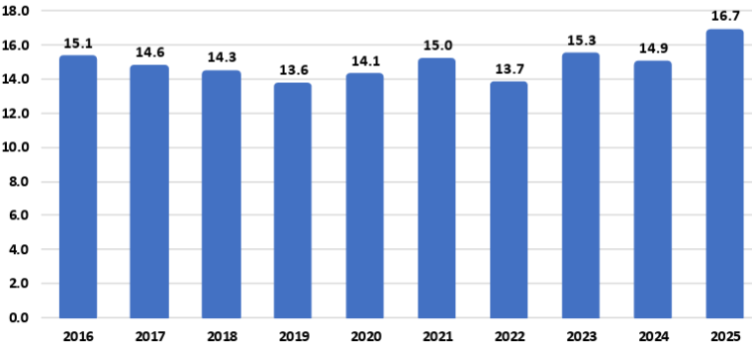
Source: USDA
For example:
The National Corn Growers Association (NCGA) is intensifying its call for action from Congress and the administration after the U.S. Department of Agriculture’s latest World Agriculture and Supply and Demand Estimates report projected a record 16.7-billion-bushel corn crop this year, further threatening the livelihood of farmers already facing record-low corn prices.
“Corn growers are already marketing their corn for extremely low corn prices, and this massive projected corn supply without market-based solutions to increasing corn demand is already causing corn prices to fall further,” said Illinois farmer and NCGA President Kenneth Hartman Jr. “Because we need markets fast for this supply, we are redoubling and intensifying our call for Congress to pass pending E15 legislation that will allow for year-round consumer access to higher blends of ethanol and for the Trump administration to quickly broker deals that will open new foreign markets for corn.”
Today’s WASDE report projects average corn yields of 188.8 bushels per acre for 2025, for an overall crop of 16.7 billion bushels. If the projections prove accurate, this year’s crop will be the largest on record by far: 1.4 billion bushels above the current production record set in 2023, a 9.1 percent increase.
An immediate boost to demand would be the passage of legislation authorizing year-round consumer access to 15 percent ethanol blend, or E15. This solution comes at no cost to consumers, requires no additional infrastructure developments and would generate demand for an additional 457 million bushels of corn, according to NCGA estimates.
NCGA is also pushing the administration to quickly broker additional deals with other countries and finalize details on deals already announced. For example, India, Vietnam and Kenya are all strategically important markets to U.S. corn growers.
Sen. Joni Ernst, R-Iowa, on July 31 introduced the Ethanol for America Act, a bill that aims to make it easier for Americans to fuel their vehicles with domestically produced E15. Companion legislation was introduced the following day by Rep. Adrian Smith, R-Neb.
The legislation would eliminate unnecessary barriers to E15 by requiring the U.S. EPA to finalize rulemaking from 2021 to make the E15 fuel label clearer and more consumer oriented. It would also confirm the compatibility of E15 with existing underground fuel storage and dispensing equipment.
Currently, fuel dispensers offering E15 must feature a label designed to alert customers to the appropriate and lawful use of the fuel. The proposed rule, issued in January 2021, co-proposes to either modify the E15 label or remove the label requirement entirely. The EPA opened a 90-day public comment period on the proposal but has failed to take final action on the rulemaking.
Following its introduction, the Senate bill, S. 2591, was referred to by the Senate Committee on Environment and Public Works. To date, Sens. Amy Klobuchar, D-Minn.; Deb Fischer, R-Neb.; Chuck Grassley, R-Iowa; Tammy Duckworth, D-Ill.; and Richard Durbin, D-Ill., have signed on to cosponsor the bill. The House bill, H.R. 4864, was referred to the House Committee on Energy and Commerce. Reps. Nikki Budzinski, D-Ill.; Dusty Johnson, R-S.D.; Tracey Mann, R-Kan.; Derek Schmidt, R-Kan.; Mike Flood, R-Neb.; Randy Feenstra, R-Iowa; and Brad Finstad, R-Minn., are cosponsoring the House bill.

Vietnam Opening Market to Ethanol
To boost ethanol imports from the U.S. tenfold to approximately 290 million gallons, the Vietnam Biofuel Association has proposed that the government swiftly implement a nationwide E10 biofuel gasoline program.
The Vietnam Biofuel Association recently submitted a document to the Domestic Market Management and Development Department (under the Ministry of Industry and Trade), addressing several issues related to the import tax on 99 percent ethanol used for biofuel blending, as well as the broader context of tariff negotiations and trade relations between Vietnam and the United States.
According to the association, the import tax on 99 percent ethanol - a type specifically used in biofuel gasoline blending - has continuously decreased from 15 percent to 12 percent, then 10 percent, and most recently to 5 percent. These reductions fall within the broader trade policy framework between Vietnam and the U.S.
Petrolimex and PVOIL, Vietnam’s two largest fuel distributors and retailers, launched the country’s first commercial trials of gasoline blended with 10 percent ethanol (E10) in three major cities last week. A total of 42 fuel stations in Hanoi, Ho Chi Minh City and Hai Phong began selling E10 RON95 gasoline as part of the trial that follows the Government of Vietnam’s recent announcement of a nationwide E10 mandate to begin in January.
“The U.S. Grains & BioProducts Council (USGBC) and its members and partners commend Petrolimex, PVOIL and the Government of Vietnam for advancing the use of fuel ethanol in Vietnam as a means to reduce harmful emissions, bolster fuel security and further stimulate rural economies,” said Ryan LeGrand, USGBC President and CEO. “This month’s rollout of E10 gasoline at retail stations is a massive step toward decarbonizing Vietnam’s transportation sector and a new potential partner for the U.S. ethanol industry and the American farmer.”
In 2018, Vietnam implemented an E5 mandate for its RON92 grade of gasoline, one of two gasoline grades widely used throughout the country. The Government of Vietnam’s decision to expand and migrate the country’s ethanol policy in 2026 to E10 and all grades of gasoline, including the more widely used RON95 grade, will help the Vietnamese fuel industry amplify the environmental and economic benefits of fuel ethanol use which augment Vietnam’s policy objectives.
Vietnam’s gasoline consumption surpassed 2.8 billion gallons in 2024, increasing 8.1 percent from 2023 consumption levels. A nationwide E10 mandate will create a total fuel ethanol demand of 280 to 300 million gallons per year, depending on gasoline demand.

USDA Land Value Report
The United States farm real estate value, a measurement of the value of all land and buildings on farms, averaged $4,350 per acre for 2025, up $180 per acre (4.3 percent) from 2024. The United States cropland value averaged $5,830 per acre, an increase of $260 per acre (4.7 percent) from the previous year. The United States pasture value averaged $1,920 per acre, an increase of $90 per acre (4.9 percent) from 2024.

Average Farm Real Estate Value (Dollars)
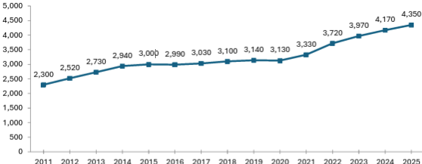
Source: USDA NASS

Farm Real Estate Value by State
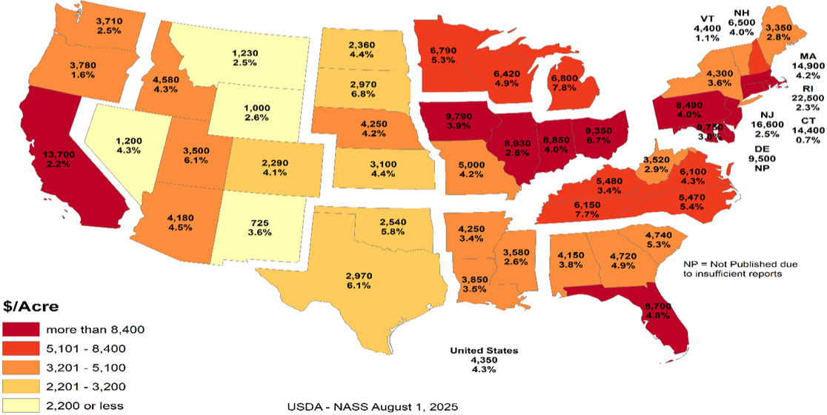
Like overall farm real estate values, average U.S. cropland values rose to record levels in 2025, reaching $5,830 per acre. This marks a 4.7 percent increase over 2024, nearly identical to the previous year’s growth but slower than the sharper increases earlier in the decade. In dollar terms, cropland values rose by $260 per acre year over year. Regional patterns remain consistent with broader farmland trends, with California and Northeastern states reporting the highest average cropland values. These are followed by much of the Midwest and Florida, the latter reflecting strong specialty crop production and ongoing residential development pressures. The top three states in percentage growth were Utah (9.7 percent), Michigan (8.2 percent) and Tennessee (7.8 percent). Notably, no states recorded a decline in cropland values.

Average Cropland Value (Dollars)
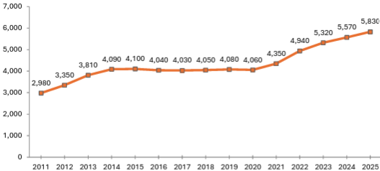
Source: USDA NASS

Cropland Value by State
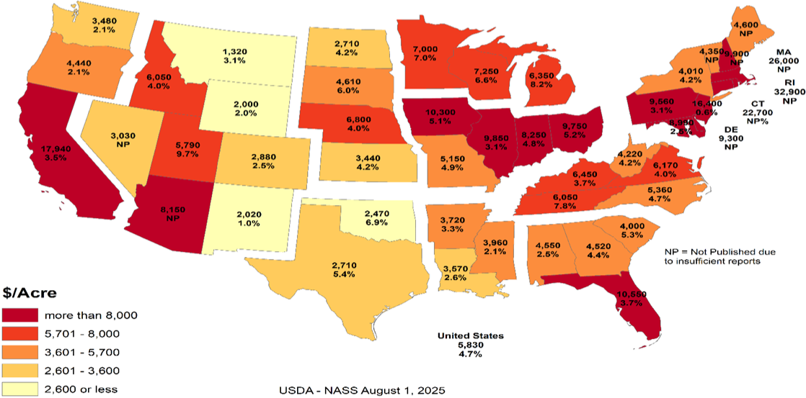
U.S. pastureland values continued their upward trend in 2025, rising to $1,920 per acre, a 5 percent increase over 2024. This growth is nearly in line with last year’s 5.2 percent gain but remains below the 6.7 percent increase in 2023 and the sharp 11 percent jump in 2022, which followed nearly a decade of stagnant values.
Unlike cropland and overall farm real estate, pastureland values are highest along the East Coast and mid-South, where development pressures, land scarcity and lifestyle demand contribute to elevated prices. In contrast, Western and Plains states report lower average values, partly due to lower land productivity and the prevalence of federally owned grazeable land accessed through grazing permits, which reduces market-based competition. In densely populated Eastern states, fragmentation of land and rising competition for open space (whether for grazing, recreation or rural living) continue to drive up per-acre costs for the limited private pastureland available.

Average Pasture Value (Dollars)
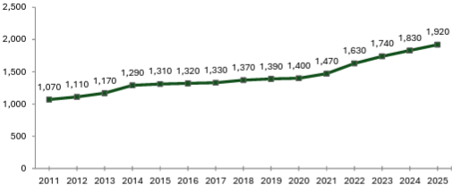
Source: USDA NASS

Pasture Value by State
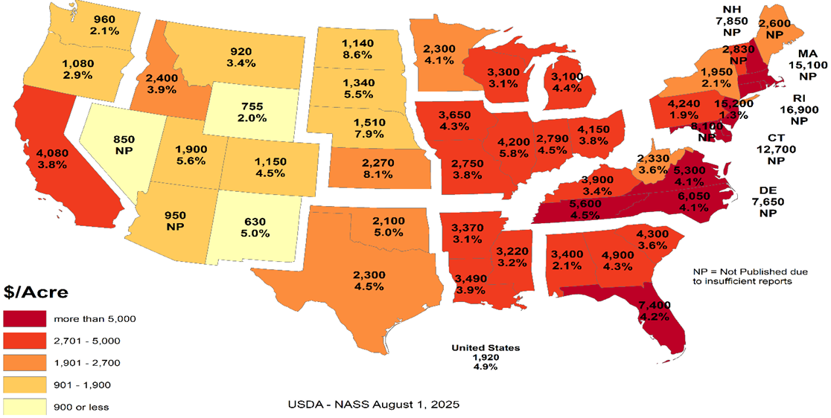

Cash Rents
American Farm Bureau summarized the USDA NASS cash rent survey.
NASS also released data on cash rents, which tend to lag changes in land values and commodity prices due to early-season lease negotiations. While the reported figures reflect past agreements, they often serve as important benchmarks for future producer-landlord negotiations, especially in areas with variable rent structures. Average U.S. cropland rent increased to $161 per acre in 2025, a modest 0.6 percent rise over 2024 — just $1 per acre. Irrigated cropland rents declined by 0.4 percent to $244 per acre, while non-irrigated rents rose 0.7 percent to $147 per acre. Pastureland cash rents remained unchanged at $15.50 per acre.
Despite minimal national movement, pressures on open land for solar development, suburban expansion and recreation continue to support rental rate growth in select areas, particularly where demand for working land is layered with lifestyle or energy investment interest. Increased telework continues to pull buyers and lessees into rural areas, intensifying local competition for land in certain high-amenity or fast-growing regions.
While earlier rent increases were tied closely to the 2021–2022 commodity price boom, today’s changes are more uneven, shaped by regional water constraints and shifting cropping patterns. In some areas, recent federal disaster assistance may have tempered pressure to renegotiate downward, even as commodity prices weaken and input costs remain high.

Cropland Cash Rent Value by State (Percent Change)
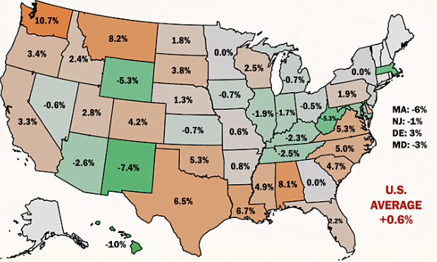
Source: American Farm Bureau, USDA NASS
Washington and Montana led the country in cropland cash rent growth, up 10.7 percent and 8.2 percent, respectively, followed by Alabama at 8.1 percent. Meanwhile, cropland rents in Hawaii, New Mexico, Wyoming, West Virginia and Massachusetts declined by more than 5 percent, likely due to a mix of stabilized drought conditions, changing land use priorities and rebalancing after years of sharp growth.
By value, the most expensive cropland rents remain in states with high-value specialty crops, such as California ($346/acre), Arizona ($334/acre) and Hawaii ($295/acre), often driven by contracts tied to irrigation infrastructure and water rights. Iowa, Illinois, Indiana and Washington round out the next tier of high-rent states, reflecting both row crop concentration and specialty crop presence. Water access and cost continue to be major drivers of both land value and rental rates across the Western U.S.
Margins for producers who rely heavily on rented land remain precarious, especially as revenue potentially slips while fixed costs (including rents) remain elevated or inflexible. Beginning farmers and those without land equity are especially exposed, facing steep barriers to accessing operating credit. In a year where net farm income is forecasted to decline without ad hoc support, even modest increases in rental rates can have outsized financial consequences.

Conclusion
Rural land values are experiencing a price bubble. In many of the Corn Belt states the cropland value continues to increase while the cash rent decreases. The values represent the impact of government land-based farm programs and ad hoc payment that could go to landowners. The government incentives to buy land have diminished the link between land values and real agricultural value. The result is farmers who rent land are increasingly in financial distress. As farmers exit the market, the disconnect between the land prices and cash rents will increase.
What the government gives it can take away. The Democrat party can win without the farm vote. Their messaging is trending away from “preserving family farmers” to “bashing Big Ag.” If rural land prices start declining, the floor is real agricultural value. For example, Illinois cash rent for cropland is $264 per acre. Farmdoc crop budget indicates that if a cash rent farmer needs $100 profit per acre to survive, the cash rent should be approximately $133 per acre or a decrease of approximately half. Assuming a 5 percent rate of return, the real agricultural value for cropland in Illinois is $2,660 per acre versus $9,850 per acre.
The other concern is that many of the new land buyers are investors. The investors are helping to drive land prices higher. When land values decrease, will the investors sit tight or take a profit? The investors do not have the same emotional attachment to the land. Farmers who want to own their own land act as a “put” under the land market. The good news is the farmers currently have low debt levels. This means the farmers have access to cash to buy land. The unknown is if the farmers are making a good investment or trying to catch a falling knife.

Cropland Cash Rent Value by State
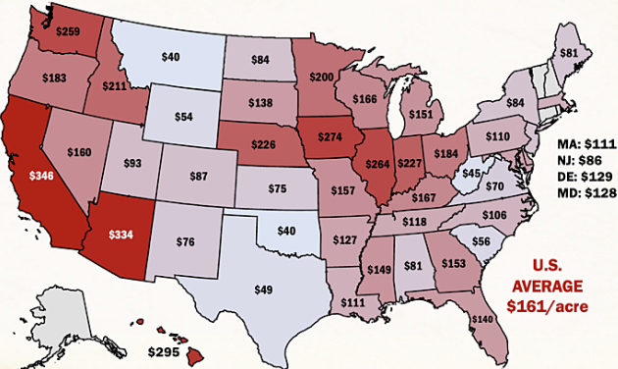
Source: American Farm Bureau, USDA NASS

Farmer Sediment
The Purdue University-CME Group Ag Economy Barometer index declined for the second month in a row. The July index fell 11 points below June’s reading and was fueled by U.S. farmers’ weaker perceptions regarding both current conditions and their expectations for the future. The July Current Conditions Index fell 17 points while the Future Expectations Index declined 7 points, both compared to a month earlier. Weaker income prospects in 2025 were largely responsible for farmers’ weaker appraisal of current conditions. Although all three principal farmer sentiment indices were lower in July than a month earlier, producer sentiment remains much more positive than at this time last year, with nearly three-quarters of July’s survey respondents reporting that the U.S. is headed “in the right direction.” The July barometer survey took place from July 7-11, 2025.
Concerns about weak income prospects in 2025 were evident in the July survey as the Farm Financial Performance Index fell 14 points compared to a month earlier. This month’s decline left the index at a reading of 90, indicating that more farmers expect weaker rather than stronger income in 2025 compared to 2024. Weakening crop prices are eroding income prospects. For example, in the Eastern Corn Belt, bids for fall harvest delivery of corn and soybeans were 7 percent and 3 percent lower during the July survey week, respectively, than just 4 weeks earlier. In turn, the decline in farmers’ income prospects helped push the Farm Capital Investment Index down 7 points in July to a reading of 53.

Farm Financial Performance Index
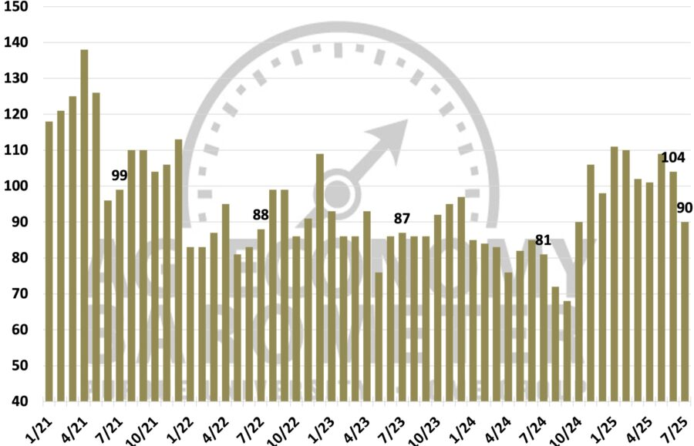
Source: Purdue/CME Group Ag Economy Barometer
Unsurprisingly, a weaker income outlook led to a softer outlook for farmland values in the upcoming year. The Short-Term Farmland Value Expectations Index dipped 5 points below a month earlier. This month’s reading of 115 also left the index 3 points lower than a year earlier and 10 points below two years ago. The farmland index’s weakness was attributable to a small shift among respondents away from expecting values to rise to looking for weakening values in the upcoming year, while the percentage expecting values to hold steady rose just one point to 57 percent. With farmland leasing discussions for next year underway between farmers and landowners, this month’s survey included a question regarding crop producers’ expectations for farmland cash rental rates in 2026. Despite weakening crop income prospects, nearly three-fourths (73 percent) of respondents said they expect cash rental rates in 2026 to remain about the same, with just 11 percent of crop producers indicating they expect rental rates to decline.
One supporting factor for both farmland values and farmland cash rental rates could be producers’ expectations regarding the farm income safety net provided by U.S. farm programs. In this month’s survey, 31 percent of respondents said they expect the safety net in the 2025 Farm Bill to be stronger than in the previous Farm Bill.
U.S. farmers in July were somewhat more optimistic about future agricultural trade prospects than a month earlier. This month, 43 percent of respondents said they expect agricultural exports to increase in the upcoming five years, up from 41 percent a month earlier. Fewer producers said they are looking for exports to decline, dropping to 13 percent of respondents, down from 16 percent who felt that way in June. In a related question, 64 percent of this month’s survey respondents said they think it likely that new foreign export markets will open to American agricultural goods in the next five years. To further gauge U.S. farmers’ outlook regarding trade and policy, this month’s survey included the following question: “Would you say things in the United States today are generally headed in the right direction or on the wrong track?” Seventy-four percent of respondents said the U.S. is headed in the “right direction.”
U.S. farmers’ sentiment declined in July as weaker farm income prospects dimmed producers’ view of current conditions and their future expectations. Despite a weaker crop income outlook, just 11 percent of crop producers said they expect farmland cash rental rates to decline, with a majority reporting that they expect rental rates to stay about the same. Helping to support producers’ farmland value and rental rate outlook is farmers’ expectation for a stronger farm income safety net, with nearly one-third (31 percent) of U.S. producers saying they expect the 2025 Farm Bill to provide a stronger safety net than the previous Farm Bill. Producers in July were somewhat more optimistic about U.S. agricultural trade prospects than in June, while nearly three-fourths (74 percent) of U.S. farmers responding to the survey reported that they feel that things in the U.S. are headed “in the right direction.”

Bunge Buys IFF Crush Division
As part of its second quarter results disclosure, International Flavors & Fragrances Inc. announced that it has entered into a definitive agreement to divest its soybean crush, concentrates, and lecithin business to Bunge Global S.A. The transaction includes operations that generated approximately $240 million in revenue in 2024 and employs around 250 people globally. The sale aligns with IFF’s strategy to strengthen its portfolio and supports the ongoing evaluation of strategic alternatives for its Food Ingredients segment, with a focus on maximizing shareholder value.

Greenhouse Gas Phase 3 Standards do not Apply to Human Health
The industry has an aftertreatment system for EPA's 2007 and 2010 Heavy-Duty Highway Engines and Vehicle emissions reduction regulations, which set standards for not only NOx but also particulate matter (PM). It also mandated the use of advanced emission control technologies like selective catalytic reduction (SCR) and diesel particulate filters. "Completely separate," said North American Council for Freight Efficiency Executive Director Mike Roeth. "Aftertreatment is not a direct GHG solution. We tend to call NOx and PM pollutant emissions, and they are directly attached to human health; breathing in these in the air... Carbon/GHG is different in that it affects climate, encouraging our more frequent and harsher weather events causing other health concerns."
Daimler Truck North America (DTNA) noted in a statement to Commercial Carrier Journal (CCJ) that the proposal does not modify EPA's existing requirements for criteria pollutants, including NOx and PM. NOx and PM standards remain in place, and they continue to be enforced independently of any changes to GHG regulations. "Selective Catalytic Reduction (SCR) systems, Diesel Exhaust Fluid (DEF), and aftertreatment technologies are essential components designed to reduce nitrogen oxides (NOx) regulated under the EPA's Clean Air Act," added Paccar companies Kenworth and Peterbilt. "The current aftertreatment systems related to NOx are still required to meet EPA and CARB standards and are independent of greenhouse gas (GHG) specific mandates."
Covered in the Endangerment Finding is nitrous oxide (N2O). NOx is shorthand for nitric oxide (NO) and nitrogen dioxide (NO2), the nitrogen oxides most relevant for air pollution. NOx itself is not considered a greenhouse gas; rather it plays a role in the formation of ozone, a naturally occurring greenhouse gas. Thus, NOx is not a greenhouse gas and the aftertreatment system, including DEF, would not be affected by this pending regulatory change.
However, EPA Administrator Lee Zeldin said in March his office intends to revisit portions of the Biden-era Clean Trucks Plan, which includes the 2022 Heavy-Duty NOx rule – a standard that includes new, more stringent emissions standards that cover a wider range of heavy-duty engine operating conditions and requires these more stringent emissions standards to be met for a longer period of time.

DEF Guidance Clarification
Starting in the early 2010s, regulations required all new on-road diesel vehicles, tractors, trucks, buses, ships, locomotives, gas turbines and construction equipment, to install additional technology to reduce nitrogen oxide emissions, a byproduct of diesel. Almost all commercial diesel transportation and equipment today has Selective Catalytic Reduction (SCR) technology that runs on DEF.
According to an EPA release, "EPA issued clear guidance urging engine and equipment manufacturers to revise DEF system software in existing vehicles and equipment to prevent these sudden shutdowns, giving operators more time to repair faults without impacting productivity or safety."
The EPA provided a chart showing derate timing for heavy duty trucks will be extended from a 5-mph limitation after just four hours' worth of a system fault to a three-stage derate:
- 15 percent torque reduction at 650 miles / 10 hours
- 30 percent torque reduction then at 4,200 miles / 80 hours
- and a final-stage derate to 25 mph at 8,400 miles / 160 hours
"In addition to providing certainty to manufacturers about how EPA wants this issue resolved, the agency is not requiring separate approvals beyond that provided in EPA’s guidance," the release said. "This ensures that bureaucratic steps do not delay manufacturers’ ability to put solutions into the field.”
Before the new EPA DEF guidance, a farmer had four hours before the vehicle or equipment stopped operating, leaving the farmer stranded. EPA’s new guidance to engine manufacturers will reduce derating, an automatic trigger forcing the engine to operate at a reduced capacity far below its capability and increase the amount of time operators must secure DEF and refuel.
Previously, farmers and truckers faced rapid engine slowdown to 5 mph within just four hours of a sensor alert. Under EPA’s new guidance for heavy-duty trucks, for example, after a fault is detected, only a warning light appears for 650 miles or 10 hours. Most significantly, there is no performance impact for at least one workday. Then, the engine only mildly derates by 15 percent, but this does not limit speed, allowing trucks to operate normally for up to 4,200 miles or two work weeks. Only after about four work weeks does speed drop to 25 mph until repairs are made. Most operators are expected to fix issues well before reaching this limit. Moving forward for farmers, non-road equipment will not experience an impact for the first 36 hours.
The ruling represents a major step up from the status quo by giving operators significantly more time to address faults before experiencing severe engine or speed limitations, which will improve their ability to complete daily operations and reduce downtime.
The revised DEF guidance is estimated to reduce farming expenses by $727 million annually. With fewer disruptions, reduced costs for emergency towing, repairs, rentals, DEF deliveries and inventories, producers will have greater operational and financial control.

Truck Manufacturers Sue CARB/California
Four of America’s top truck makers have officially filed a lawsuit in the U.S. District Court for the Eastern District of California challenging the Clean Truck Partnership (CTP) agreement signed with the California Air Resources Board in 2023. CARB has argued since the Congressional rollback of its Advanced Clean Trucks and Omnibus Low-NOx rules earlier this summer that despite the federal disapproval of the regulations, the CTP is still binding.
Cummins, Daimler Trucks North America, Hino, Isuzu, then-Navistar, Paccar, the Truck and Engine Manufacturers Association, and Volvo Group North America in July 2023 were among 11 signers of the CTP, an agreement with CARB that pledged truck and engine manufacturers will meet California’s vehicle standards and required the sale and adoption of zero-emission vehicle (ZEV) technology.
The OEMs said in the lawsuit that despite the Congressional Review Acts passed this year preempting California’s emissions standards, the state “continues to demand compliance with its heavy-duty emissions standards, and it has threatened OEMs that design, develop, manufacture and sell heavy-duty vehicles and engines ... with civil sanctions and unfavorable regulatory treatment if the OEMs refuse to comply with the state’s unlawful standards, while also taking measures to insulate itself from lawful challenges to those standards.”
Senior Clean Vehicles Advocate for the Natural Resources Defense Council Guillermo Ortiz called the lawsuit, "a cynical reversal of course. These companies helped negotiate the Clean Truck Partnership to secure regulatory certainty. Now they’re trying to dismantle the very deal they shaped -- injecting instability into a market they claim to lead," he said. "This is bad faith, plain and simple, and it raises questions about whether these manufacturers are serious about their ability to deliver clean trucks to the global stage."
The OEMs said the U.S. Department of Justice has sent them Cease & Desist letters stating that California’s enforcement of its regulations “is contrary to federal law” and directed the truck makers “to immediately cease and desist compliance with California’s preempted and unlawful mandates.”
This has left the OEMs “caught in the crossfire,” they said, as “California demands that OEMs follow preempted laws; the United States maintains such laws are illegal and orders OEMs to disregard them. This situation is not tenable.”
As such, the lawsuit aims to clarify the OEMs’ legal obligations under federal and state law and to block California from enforcing regulations that are preempted by federal law. Given the inconsistencies between federal and California regulatory requirements for emissions, truck and engine makers and their trade associations in 2023 petitioned CARB for relief from the state’s “infeasible regulatory requirements,” which resulted in the CTP, the lawsuit added. Now, according to the OEMs, “California seeks to use the Clean Truck Partnership, which was intended to harmonize compliance with state and federal law, to compel an entire industry to follow California emissions standards that are now in conflict with federal law, and which have been expressly preempted by federal law.” They added that the state is disregarding the CTP’s “plain language,” which “states that manufacturers are obligated to follow CARB’s emissions regulations ‘regardless of the outcome of any litigation challenging … those regulations, or CARB’s overall authority to implement those regulations,’ not federal legislative action taken to invalidate them.”
The regulatory back-and-forth between the federal government and California/CARB has put OEMs “in an impossible position,” they said in the lawsuit. “As a result, the OEMs are subject to two sovereigns whose regulatory requirements are irreconcilable and who are openly hostile to one another. Each wields a hammer to enforce its will on industry, leaving OEMs -- who simply seek to sell heavy-duty trucks in compliance with the law -- unable to plan with the necessary certainty and clarity where their products need to be certified for sale and by which regulatory authority.”
California, citing the CTP, has contended that in order for OEMs to legally sell trucks in the state, they must obtain certification from CARB. Yet the OEMs said this process “takes months,” adding that they “need to know within a matter of weeks whether they must obtain a model year 2026 certification from CARB in order to lawfully sell their products in California and other opt-in states, which together represent approximately 25 percent of the national market for new vehicle registrations for heavy-duty vehicles.”
In filing the lawsuit, the truck makers said they are looking for “declaratory and injunctive relief with the goal of clarifying and establishing the regulatory obligations that they must follow to lawfully offer products for sale in California and the various opt-in states, and to prevent California officials from violating their constitutional rights,” adding that “an expeditious decision is essential.”
The OEMs’ lawsuit joins another suit brought by the Western States Trucking Association that challenged CARB’s authority to enforce the CTP following the federal preemption of the regulations.

Ambassador Jamieson Greer: Why We Remade the Global Order
The following op-ed provides the foreign policy vision of the Trump Administration. On the 200-day mark of the second Trump administration, United States Trade Representative Jamieson Greer published an op-ed in The New York Times explaining how President Trump’s trade policy is remaking the international economic order to reduce our trade deficit and deliver lasting benefits for American workers and industries.
The full text of the op-ed is below:
It must be an unwritten rule that international economic orders emerge at stately hotels. In 1944, as World War II raged, Allied representatives gathered at a picturesque New Hampshire resort named Bretton Woods to discuss how to establish a postwar economic order to restore the sensible flow of trade in a fractured world.
Although the resulting Bretton Woods system ended in 1976, its legacy lives on. Our current, nameless global order, which is dominated by the World Trade Organization and is notionally designed to pursue economic efficiency and regulate the trade policies of its 166 member countries, is untenable and unsustainable. The United States has paid for the system with the loss of industrial jobs and economic security, other countries have been unable to make needed reforms, and the biggest winner has been China, with its state-owned enterprises and five-year plans. Unsurprisingly, the past decade has seen significant international and bipartisan American frustration at the system’s failure to adapt to meet the essential interests of sovereign nations.
Now, reform is at hand. Last week at his Turnberry resort on the Scottish coast, President Trump and the European Commission president, Ursula von der Leyen, concluded a historic agreement — one that is fair, balanced and oriented toward serving concrete national interests rather than vague aspirations of multilateral institutions. Indeed, by using a mix of tariffs and deals for foreign market access and investment, the United States has laid the foundation for a new global trading order.
The previous system rejected tariffs as a legitimate tool of public policy, meaning that the United States sacrificed tariff protection for critical manufacturing and other sectors. Over the past three decades, the United States slashed barriers to our market to allow vast inflows of foreign goods, services, labor and capital. At the same time, other countries kept their markets closed to our goods and deployed a suite of policies — such as subsidies, wage suppression, lax labor and environmental standards, regulatory distortions and currency manipulation — to artificially boost exports to the United States. This approach made the United States and a handful of other economies the consumers of last resort for countries pursuing beggar-thy-neighbor economic policies.
Our trading partners were adept at this game, and elites on Wall Street and in Washington were all too happy to cash in on the global arbitrage by moving production abroad. The net result? The bulk of global manufacturing shifted to jurisdictions such as China, Vietnam and Mexico where companies could exploit vulnerable workers or benefit from expansive state support while the United States ran up what in absolute terms is the highest trade deficit in the history of the world. This led to extensive and well-documented losses in U.S. industrial capacity and employment as well as reliance on our adversaries for critical supply chains.
We subordinated our country’s economic and national security imperatives to a lowest common denominator of global consensus. This approach harmed American workers, their families and communities by undermining a manufacturing sector that creates high-wage jobs, fosters innovation and catalyzes investment across the economy.
What began at Bretton Woods as a necessary effort to rebuild a global trade system shattered by war evolved, over nine rounds of trade negotiations, into something unrecognizable. The measured guidelines for commerce developed in the Kennedy and Tokyo Rounds gave way to our recent experiment in global hyper-integration, embodied in the Uruguay Round, which concluded in 1994 and established the W.T.O.
We are now witnessing the Trump Round. On April 2, President Trump announced tariffs to address the national emergency posed by the trade deficit. The intense bilateral negotiations that followed were held in diverse locations across the world: Washington, Geneva, Jeju Island, Paris, London, Stockholm and, of course, Turnberry. Our trading partners had never before shown such interest in opening their markets to the United States, aligning on matters of economic and national security, and rebalancing trade in a more sustainable direction. In a few short months, the United States secured more foreign market access than it had in years of fruitless W.T.O negotiations.
Reversing decades of harmful policy that weakened our manufacturing capacity and work force will take time and coordinated effort across the public and private sectors. But keeping the status quo would only accelerate the dangerous trajectory of deindustrialization. We require a generational project to re-industrialize America, and time is short.
When I joined a critical mass of my fellow trade ministers in June at a meeting of the Organization for Economic Cooperation and Development in Paris, I was struck by how many voiced serious concerns about the danger of macroeconomic imbalances, the threat of nonmarket practices and the sclerotic state of the global trading system — the same issues President Trump has raised for years and now taken emergency action to address. What was long dismissed as heresy by the free-trade fundamentalists in Brussels, Geneva and Washington is now becoming conventional wisdom.
In announcing the U.S.-European Union deal last week, President von der Leyen echoed the call to refashion global trade to adapt to economic and political realities. She explained to reporters that the trans-Atlantic economic relationship needed “rebalancing” to ensure that it could be “more sustainable.” Such recognition is reinforced by additional deals with Britain, Cambodia, Indonesia, Japan, Malaysia, Pakistan, the Philippines, South Korea, Thailand and Vietnam, which make up almost 40 percent of U.S. trade, according to my office’s figures. Other countries with large trade surpluses with the United States are subject to generally higher tariffs. The new economic order, solidified at Turnberry, is emerging in real time.
The results are astounding. Every year for 40 years, the Office of the U.S. Trade Representative has produced a detailed report called the National Trade Estimate chronicling various barriers faced by U.S. companies, including high tariffs, requirements to produce goods in the countries where the companies want to do business, and restrictions on agricultural products contrary to scientific consensus. In the past, the only significant way the United States could remove these barriers (if at all) was by giving away the tariffs defending our manufacturing sector. President Trump has flipped the script on this: Now, we are systematically eliminating these barriers abroad while ensuring sufficient tariff protection at home.
Indonesia is lowering 99.3 percent of its tariffs on imports from the United States and eliminating a slew of longstanding non-tariff barriers, while accepting a 19 percent tariff on exports to the United States. South Korea is accepting U.S. auto standards along with a 15 percent tariff. Vietnam pledged to lower all of its tariffs and barriers in exchange for a 20 percent rate. Most countries we are negotiating with have also agreed to cooperate on economic security to ensure the safety and reliability of our critical supply chains.
Countries are also committing to upgrade and better enforce their labor standards, tackling arbitrages that have put American workers and producers at a disadvantage. Multiple countries will join the United States (along with the E.U., Mexico and Canada) in banning the importation of goods made with forced labor. Eliminating global slavery was a longstanding goal of advocates and policymakers, but it was the leverage of President Trump’s tariffs that finally made it possible to unlock meaningful progress.
Similarly, countries are agreeing to improve resource efficiency and enforcement of environmental laws, including in the most problematic sectors, such as illegal logging, illegal fishing and the illegal wildlife trade. The international trade system should not force Americans to compete with those who use our responsible capitalism against us as a competitive advantage.
Importantly, these commitments are actionable, and the United States will enforce them. Rather than the drawn-out dispute settlement process favored by the old guard of trade bureaucrats, the new U.S. approach is to closely monitor implementation of the deals and swiftly reimpose a higher tariff rate for noncompliance if needed. President Trump uniquely recognizes that the privilege of selling into the world’s most lucrative consumer market is a mighty carrot. And a tariff is a formidable stick.
At the World Trade Organization, enacting changes to trade rules requires total consensus among nations. In fact, the last attempt at serious reform, known as the Doha Round, failed because protectionist nations refused to take down their trade barriers to the United States. Moreover, our adversaries relish blocking reform. They prefer a status quo that feeds an exploding U.S. trade deficit, sapping this nation of the industrial might that made it, and keeps it, a superpower.
But the rules of international trade cannot be a suicide pact. By imposing tariffs to rebalance the trade deficit and negotiating significant reforms that form the basis of a new international system, the United States has shown bold leadership to address what policymakers long considered intractable problems.
Many of these deals also come with significant investment commitments into U.S. productive capacity, such as $600 billion in the case of the European Union and $350 billion by South Korea. These investments — 10 times larger than the inflation-adjusted value of the Marshall Plan that rebuilt Europe after World War II — will accelerate U.S. reindustrialization. South Korea will help reinvigorate the American shipbuilding industry, which has atrophied in the face of nonmarket competition. These types of investments are on top of purchase commitments that cumulatively account for almost $1 trillion of American energy, agriculture, defense and industrial products. This demand for American goods and ready access to capital will allow American manufacturing to reassert leadership across strategic sectors where we have fallen behind.
Skeptics point out that tariffs, although once a fixture of American economic policy, have not been used this extensively for generations. But we now have data showing that the failure to use tariffs or similar protections created an economy that was heavy on finance and consulting fees and low on the lasting wealth and security that come from making things. Even among those who agree with that diagnosis, some say the president’s remedy is too strong or was administered too hastily, or that the tariffs will be too disruptive in the short term. This is not the time to debate how many angels can dance on the head of a pin. This is an emergency. We know what the problem is and we know how to address it. There is no time to waste.
President Trump has already shown that he can implement tariffs and other economic tools to reshape supply chains and reinvigorate manufacturing. When he deployed sweeping tariffs in his first term, not only did the sky not fall as pundits predicted, but inflation actually went down. And now that he is imposing tariffs even more broadly, inflation remains in check. A long-term problem won’t be fixed overnight, and the process may not always be smooth, but the situation demands strong and resolute action to strengthen the U.S. industrial base.
It took over 50 years from that first meeting at Bretton Woods until the creation of the W.T.O. It has been 30 years since. Fewer than 130 days from the beginning of the Trump Round, the Turnberry system is by no means complete, but its construction is well underway.

Stagflation Discussion
Stagflation talk has taken center stage. It should be remembered that stagflation in the 1970s was driven by crude oil prices increasing from $3.56 per barrel in August 1973 to $10.11 per barrel in January 1974 to $14.85 per barrel in January 1979 to $39.50 per barrel in May 1980. In less than seven years crude oil price increased by over 1,100 percent. By comparison, the current crude oil price is approximately half the May 2022 price. With almost every country expanding energy production, lower energy prices could occur.
According to the prolonged price decrease in crude oil and natural gas, inflation numbers will be below macro-economic models. This is because energy is incredibly important as it impacts inflation numbers directly, such as fuel and as a feedstock in petrochemicals, and indirectly, such as an increased cost that a manufacturer and business must recoup. Energy costs impact input prices for production, and every other stage required to reach the consumer with each cost increase being pushed to the next level. The cumulative impact of higher energy prices on the consumer tends to be understated by macro-economic models.
One inflationary outcome from lower energy prices is discretionary income increasing, which allows for more spending. The other outcome is the producer price index will show a decline with retail sales prices staying firm and retailers performing better than if it was still a higher energy cost environment. Any economic downturn will force retailers to lower prices to move products.
The inflationary impact of the massive increase in the money supply has worked its way through the economy, resulting in a natural slowdown. It is difficult to have runaway inflation with lower energy prices, and a weak housing market.
During the last trade war, the rate of inflation decreased. It is not a forgone conclusion that the rate of inflation is going to increase. The consumer price index increased a seasonally adjusted 0.2 percent for the month and 2.7 percent on a 12-month basis, the Bureau of Labor Statistics reported. That compared with the respective Dow Jones estimates for 0.2 percent and 2.8 percent.
Excluding food and energy, the core CPI increased 0.3 percent for the month and 3.1 percent from a year ago, compared with the forecasts for 0.3 percent and 3 percent. Federal Reserve officials generally consider core inflation to be a better reading for longer-term trends. The monthly core rate was the biggest increase since January while the annual rate was the highest since February.
Tariff-sensitive new vehicle prices also were unchanged. For now, automakers are choosing to keep market share.
A 0.2 percent increase in shelter costs drove much of the rise in the index, while food prices were flat and energy fell 1.1 percent, the BLS said. U.S. housing market now 508,715 more home sellers than homebuyers. With the current housing market experiencing pain, it is easier to envision lower prices not higher prices.

U.S. Consumer Price Index (Annual Change)
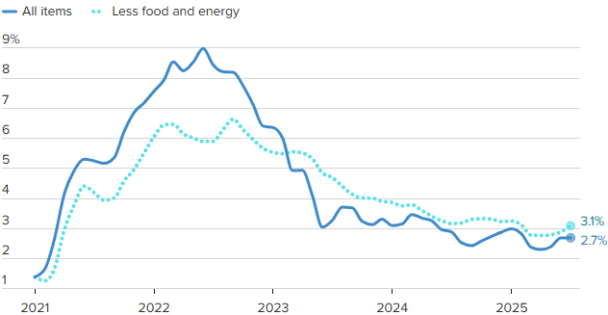
Crude Oil $120 per barrel
Source: BLS, CNBC

Estimated Number of Homebuyers and Sellers
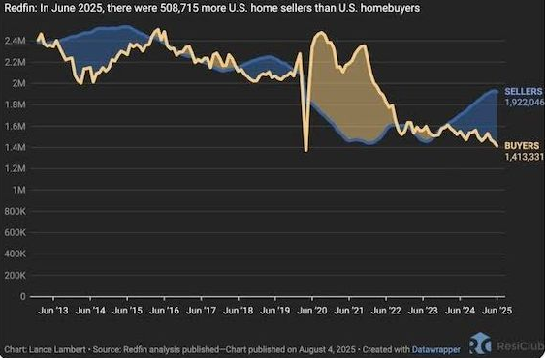

Mid-America Manufacturing Slumps for July
After six straight months of above growth neutral readings, the Creighton University Mid-America Business Conditions Index, a leading economic indicator for the nine-state region stretching from Minnesota to Arkansas, sank below 50.0 growth neutral threshold for July.

Overall Index
The Business Conditions Index, which uses the identical methodology as the national Institute for Supply Management (ISM) and ranges between 0 and 100 with 50.0 representing growth neutral, declined to 49.4 for July from 50.7 in June.
“Creighton’s latest survey continues to reflect job losses across the region, accompanied by elevated wholesale inflation,” said Ernie Goss, PhD, Director of Creighton University’s Economic Forecasting Group and the Jack A. MacAllister Chair in Regional Economics in the Heider College of Business. “Supply managers expressed growing concern that rising tariffs could further accelerate inflationary pressures. Despite these concerns, only 6.7 percent of surveyed supply managers reported shifting purchases from international to domestic suppliers in response to the tariffs.”

Employment
The July employment index fell to 45.4 from 49.4 in June, marking the fourth consecutive month below the growth-neutral threshold of 50. This sustained weakness reflects ongoing labor market challenges in the regional manufacturing sector.
“The Creighton survey has now recorded six straight months of job losses across the nine-state Mid-America region,” said Goss. “While employment rose in the first quarter—driven by increased production ahead of anticipated tariff impacts—the last four months have signaled a return to regional manufacturing job declines,” said Goss.
U.S. Bureau of Labor Statistics data show that the region shed 12,900 (-0.9 percent) manufacturing jobs over the past 12 months. The U.S. lost 89,000 (-0.7 percent) manufacturing jobs over the same time period.
Comments from Supply Managers in July:
- “Most of the suppliers I work with are dropping their production down to four-day work weeks. Nothing like a 20 percent cut in pay.”
- “I believe that the President's tariff changes are going to help our country to be better trading partners. It will take a bit of time for it all to shake out though.”
- “No changes to international purchases until a final tariff rate is in place. Certain products have been put on hold.”
- “We are not accepting pricing increases and have any tariffs added as a surcharge, so they are easy to remove.”
- “Long-term contracts have been key to holding pricing steady. Where there are extreme cost pressures with suppliers, collaboration on a resolution is the method of choice, while rare.”
- “While the Trump administration is doing everything possible to bring the economy back to its former glory, the democrats continue their seditious acts to block any attempts at dismantling their previous criminal maneuvers to destroy this great country! A reckoning is coming.”

Wholesale Prices
The July price gauge climbed to 69.7 from 67.9 in June. “The regional inflation yardstick has moved into a range indicating that inflationary pressures are moving higher at the wholesale level. However, due to a slowing regional and U.S. economies, I expect the Federal Reserve to cut interest rates at its September 16-17 meetings,” said Goss.
On average, supply managers expect tariffs to push input prices up by 7.8 percent over the next 12 months. This is up from 7.5 percent recorded in June.

Confidence
Looking ahead at the next six months, economic optimism, as captured by the July Business Confidence Index, dropped to 42.6 from June’s 50.0. “Concerns regarding tariffs and slowing new orders pushed supply managers’ expectations lower. Only one in six supply managers expect rising economic conditions for their firm over the next six months,” said Goss.

Inventories
The regional inventory index, reflecting levels of raw materials and supplies, increased to 49.1 in July from June’s 46.9. “Rapid expansions in inventories in the first quarter are now being offset by monthly pullbacks in buildups,” said Goss.

Trade
Recent uncertainty regarding tariffs and trade restrictions pushed new export orders lower for the last four months. New export orders slumped to 38.3 from 43.4 in June. As a result of record imports for the first two months of 2025, supply managers pulled back on purchasing from abroad in the last five months. The July import index increased to a still weak reading of 36.3 from 30.0 in June.
Supply managers were asked about their firm’s reactions to tariffs and threats of tariffs. Only 6.7 percent of manufacturing supply managers reported switching from international suppliers to domestic suppliers. More than one-third, or 67.0 percent, reported making no changes of suppliers due to tariffs. The remaining 26.3 percent indicated that their firms had switched from one international supplier to another international input supplier.
According to U.S. International Trade Administration (ITA) data, the regional economy exported $38.9 billion in manufactured goods for the first five months of 2025, compared to $40.8 billion for the same period in 2024, for a 4.7 percent decline. In terms of export gainers, North Dakota registered the top percentage gain with a 42.6 percent addition, and South Dakota recorded the largest percentage loss with a 19.9 percent reduction in the export of manufactured goods.

Other Survey Components of the July Business Conditions Inde
New orders dropped to 45.5 from 52.4 in June; the production or sales index increased slightly to 49.0 from 48.5 in June; and the speed of deliveries of raw materials and supplies rose to 57.8 from June’s 56.5. Higher readings indicate slower deliveries and/or rising supply chain disruptions or delays.

Arkansas
The state’s July Business Conditions Index fell to 43.0 from 48.2 in June. Components from the July survey of supply managers were new orders at 43.7, production or sales at 47.0; delivery lead time at 53.1; inventories at 39.5; and employment at 31.8. According to ITA data, the Arkansas manufacturing sector exported $2.3 billion in goods for the first five months of 2025, compared to $2.4 billion for the same period in 2024, for a 5.6 percent decline.

Iowa
The state’s Business Conditions Index for July declined to 43.7 from 48.0 in June. Components of the overall July index were new orders at 43.9; production or sales at 47.3; delivery lead time at 53.6; employment at 33.2; and inventories at 40.6. According to ITA data, the Iowa manufacturing sector exported $6.2 billion in goods for the first five months of 2025, compared to $6.9 billion for the same period in 2024, for a 10.3 percent decline.

Kansas
The Kansas Business Conditions Index for July increased to 51.1 from 49.9 in June. Components of the leading economic indicators from the monthly survey of supply managers for July were new orders at 45.5; production or sales at 50.3; delivery lead time at 58.6; employment at 47.7; and inventories at 58.6. According to ITA data, the Kansas manufacturing sector exported $5.0 billion in goods for the first five months of 2025, compared to $5.2 billion for the same period in 2024, for a 3.5 percent decline.

Minnesota
The July Business Conditions Index for Minnesota dropped to 49.3 from 52.8 in June. Components of the overall July index were new orders at 45.1; production or sales at 49.8; delivery lead time at 57.5; inventories at 50.2; and employment at 44.3. According to ITA data, the Minnesota manufacturing sector exported $9.5 billion in goods for the first five months of 2025, compared to $10.7 billion for the same period in 2024, for an 11.4 percent decline.

Missouri
The state’s July Business Conditions Index rose to 51.8 from 50.8 in June. Components of the overall index from the survey of supply managers for July were new orders at 45.6; production or sales at 50.6; delivery lead time at 59.1; inventories at 54.4; and employment at 49.2. According to ITA data, the Missouri manufacturing sector exported $7.0 billion in goods for the first five months of 2025, compared to $7.1 billion for the same period in 2024, for a 0.5 percent decline.

Nebraska
The state’s July Business Conditions Index climbed to 51.6 from June’s 51.3. Components of the index from the monthly survey of supply managers for July were new orders at 45.5; production or sales at 50.4; delivery lead time at 58.8; inventories at 53.6; and employment at 48.3. According to ITA data, the Nebraska manufacturing sector exported $2.7 billion in goods for the first five months of 2025, compared to $3.1 billion for the same period in 2024, for a 10.8 percent decline.

North Dakota
The state’s Business Conditions Index advanced above growth neutral for a 13th consecutive month to 52.2 from 52.0 in June. Components of the overall index for July were new orders at 45.7; production or sales at 50.8; delivery lead time at 59.4; employment at 50.0; and inventories at 55.0. According to ITA data, the North Dakota manufacturing sector exported $2.5 billion in goods for the first five months of 2025, compared to $1.8 billion for the same period in 2024, for a 42.6 percent gain.

Oklahoma
The state’s Business Conditions Index for July declined to 49.0 from 50.6 in June. Components of the overall July index were new orders at 45.0; production or sales at 49.5; delivery lead time at 57.2; inventories at 49.7; and employment at 43.7. According to ITA data, the Oklahoma manufacturing sector exported $2.9 billion in goods for the first five months of 2025, compared to $2.6 billion for the same period in 2024, for a 3.5 percent gain.

South Dakota
The July Business Conditions Index for South Dakota slumped to 44.5 from 48.5 in June. Components of the overall July index were new orders at 44.1; production or sales at 47.6; delivery lead time at 54.1; inventories at 42.1; and employment at 34.8. According to ITA data, the South Dakota manufacturing sector exported $0.7 billion in goods for the first five months of 2025, compared to $0.9 billion for the same period in 2024, for a 19.9 percent decline.

Corn
Fundamental Recommendation: Corn has traded toward the upper end of the recent range as seasonal strength and early South American weather concerns support the market. However, with global stocks expected to rebuild and U.S. export competitiveness constrained, rallies are likely to fade. Sell any contract above $4.85, particularly July 2026, as the forecast projects prices peaking near $4.90 before easing into the second half of 2026.

Fundamental Bullish Factor – Despite the lack of official USDA data in prior weeks, weekly ethanol corn grind has remained robust, tightening traders’ expectations for U.S. stocks-to-use ratios.
Fundamental Bullish Factor – Cattle margins remain historically high, and competition from Argentine imports will likely accelerate the recovery in the cattle cycle, supporting additional feed demand..
Fundamental Bearish Factor – The return of USDA data may shift market attention back toward ample global supply, after several weeks in which sentiment was driven primarily by demand indicators.
Fundamental Bearish Factor – The U.S. remains uncompetitive in export markets, with Brazil and Argentina offering more attractive corn to global buyers.
Fundamental Swing Factor – Potential revisions to U.S. biofuel policy and the development of SAF technology.
Fundamental Swing Factor – Changes in U.S. export competitiveness as the South American seasonal export window begins to close.

Technical Recommendation: Sideways to Lower.

Technical Bullish Factor – Relative strength index is oversold and at levels that have indicated price bottoms in the past.
Technical Bullish Factor – Solid chart support just below present prices.
Technical Bullish Factor – Massive crop overwhelming technicals.
Technical Bearish Factor – Prices still in downtrend in place on daily bar chart.
Technical Bearish Factor – Prices well below key 40-day moving average.
Technical Bearish Factor – Longer-term price charts are bearish.
Corn (continued)

CBOT Corn Technicals
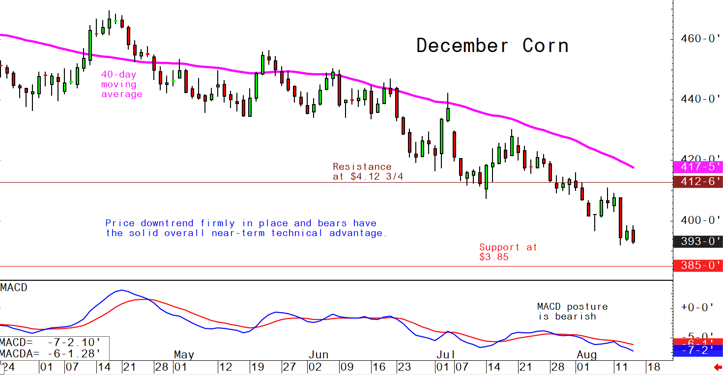
Wheat
Fundamental Recommendation: The balance sheet suggests lower prices, even with weather risk premium added, so we would carefully try to establish shorts in Sep 26. Liquidity and the robust cash-market demand for row crops continue to keep upside risk above levels suggested by the balance sheet. So, balance any short in Sep with inexpensive 10-delta calls in the nearby as a hedge, as long as volatility is not too expensive.

Fundamental Bullish Factor – Strong world wheat demand supporting export basis
Fundamental Bullish Factor – Developing dryness around major winter wheat areas, particularly ECB and Illinois will support strength from cash markets.
Fundamental Bearish Factor – USDA raised global production more than anticipated
Fundamental Bearish Factor – Russian wheat remains more competitive than other sources, limiting fresh export volumes
Fundamental Swing Factor – US weather conditions over the winter. Developing dryness surrounds major winter wheat growing areas threatening winter kill if the snow pack is absent.
Fundamental Swing Factor – Weekly export sales data will provide a window into US competitiveness and the pace of shipments.
Technical Recommendation: Sideways to Lower.

Technical Bullish Factor – Markets are short-term oversold and due for upside correction.
Technical Bearish Factor – SRW and HRW prices well below key 40-day moving averages.
Technical Bearish Factor – SRW and HRW prices in downtrends on daily charts.
Technical Bearish Factor – Down-trending corn market is bearish for wheat.

Wheat (continued)

CBOT Wheat Technicals
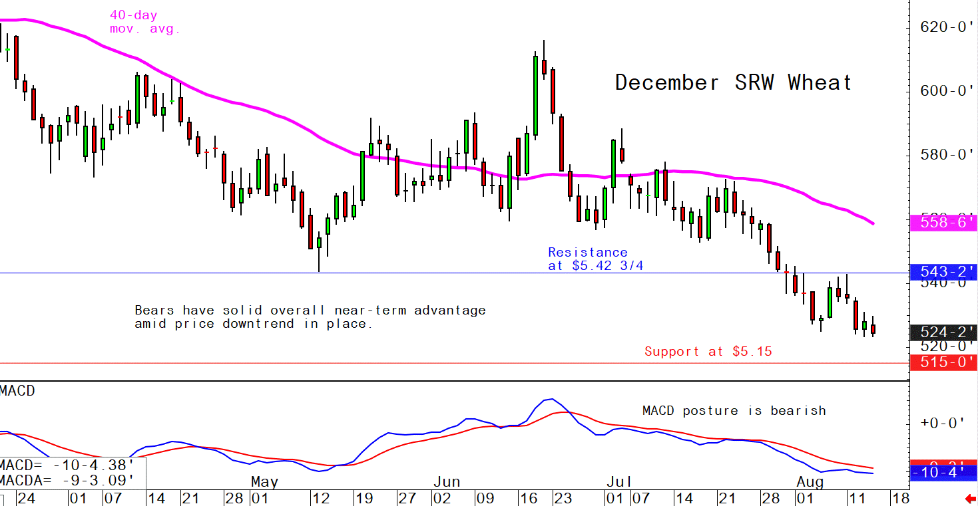

Soybeans
Fundamental Recommendation: Like the other row crops, the manic nature of traders’ responses to the “more bearish than expected, but still kind of bullish in a certain light,” means it is not a time for unhedged positions. If Brazilian production hits 175 million tonnes, selling into any increase in prices driven by the additional of seasonal weather risk premium will be wise. However, robust cash demand and nearly tight ending stocks encourage hedging with tiny calls (10-delta) in the nearby contract.

Fundamental Bullish Factor – Robust domestic US demand continues to support basis.
Fundamental Bullish Factor – Chinese buying has been viewed by the market as bullish with recent purchases driving the post WASDE recovery in prices.
Fundamental Bearish Factor – South American farmers are likely to produce another record-large crop.
Fundamental Bearish Factor – Chinese soybean meal demand remains lower than anticipated.
Fundamental Swing Factor – The volume of Chinese buying before the end of the year. It remains unclear that China needs 12.5 million tonnes of soybeans and despite recent purchases remains well short of the target heading into the holiday season.
Fundamental Swing Factor – Limited but potentially serious weather risk. Limited dryness in South America and growing dryness in the heart of the Corn Belt remain critical areas to watch.

Technical Recommendation: Sideways.

Technical Bullish Factor – Prices now above key 40-day moving average.
Technical Bullish Factor – Soybean meal market now performing much better.
Technical Bullish Factor – MACD indicator turns bullish.
Technical Bearish Factor – Slumping corn and wheat markets are bearish for beans.
Technical Bearish Factor – Longer-term charts are not friendly for beans.

Soybeans (continued)

CBOT Soybeans Technicals
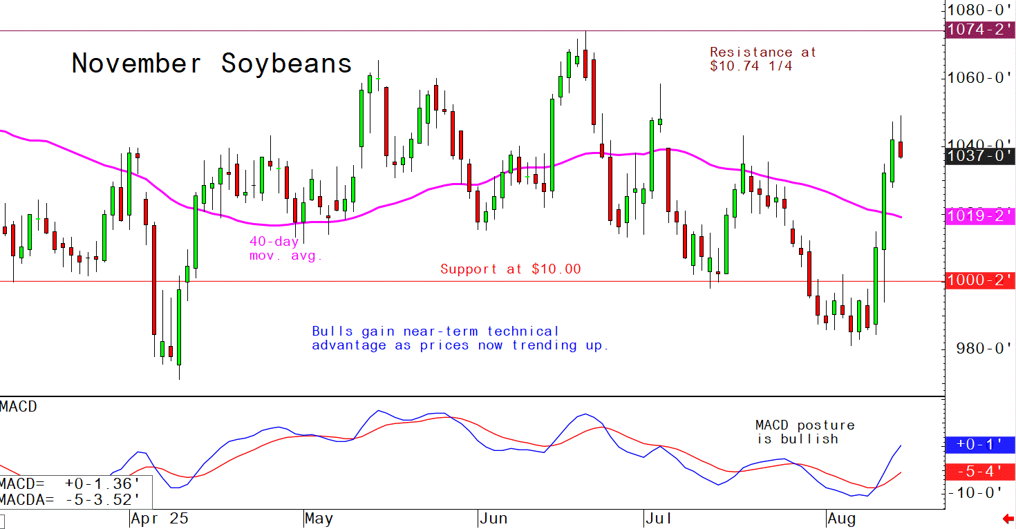
Soybean Meal
Fundamental Recommendation: Limited opportunities given robust domestic demand, but short Oct above $350 may be the only spot. Still, if weather concerns develop in South America or the Corn Belt, prices could move sharply high so limit risk by reducing position size or hedging.

Fundamental Bullish Factor – Cattle prices remain historically high, shifting consumer demand to pork and chicken, which both consume substantially more soybean meal per animal than cattle.
Fundamental Bullish Factor – Crushers continue to keep the domestic protein meal market tight enough to avoid crushing for oil.
Fundamental Bearish Factor – Record South American oilseed production will potentially substantially increase competition for soybean meal exports in 2025/26.
Fundamental Bearish Factor – Changes in biofuel policy announced early in the Trump Administration increase the potential demand for soybean oil, increasing the possibility that crushers could be driven to crush for oil by mandate.

Technical Recommendation: Sideways to Higher.

Technical Bullish Factor – Prices now trending up on daily bar chart.
Technical Bullish Factor – Prices above key 40-day moving average.
Technical Bullish Factor – Spreaders are unwinding short meal, long bean oil spreads.
Technical Bearish Factor – Market is short-term overbought, technically.
Technical Bearish Factor – Longer-term charts are not bullish.

Soybean Meal (Continued)

CBOT Soybean Meal Technicals
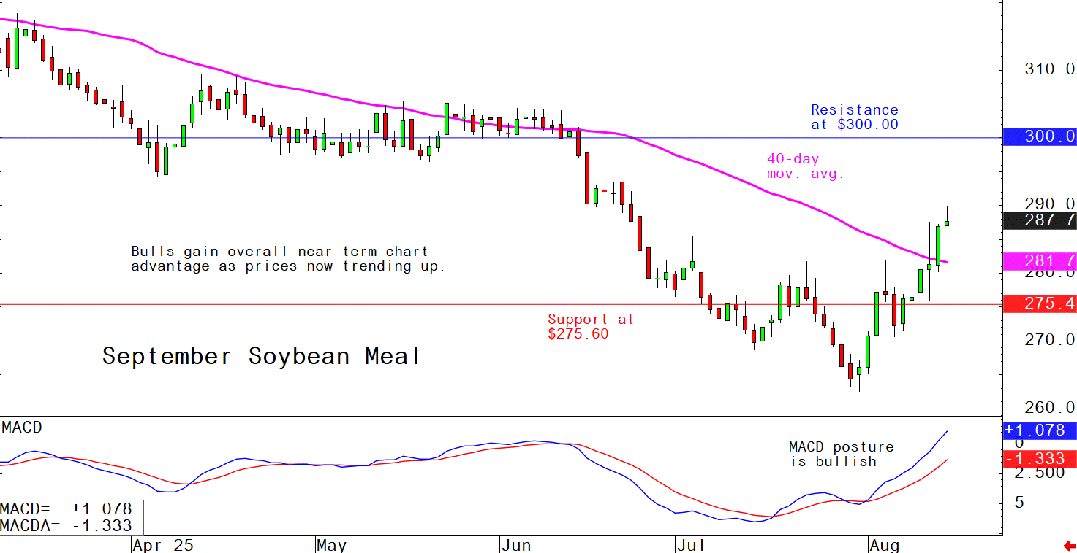

Soybean Oil
Fundamental Recommendation: Forecast models want to predict December substantially below our current outlook. Sell Dec above 60 cents, but if the South American crop is as large as expected that target may need to drop to 55 cents by the end of January.
Fundamental Bullish Factor – Continued demand pull from biofuel producers support domestic prices.
Fundamental Bullish Factor – Concerns about growing tightness in world vegetable oil markets due to production concerns with palm that are currently limited but could grow.
Fundamental Bearish Factor – Record South American production could limit the competitiveness of US exports in 2025/26.
Fundamental Bearish Factor – Falling crude prices could pressure margins heading into the time of the year when output, particularly at biodiesel plants slows dramatically.

Technical Recommendation: Sideways to Lower.

Technical Bullish Factor – Solid chart support levels just below the market.
Technical Bullish Factor – Rallies in soybeans and meal will limit downside in bean oil.
Technical Bullish Factor – Weekly chart is still friendly.
Technical Bearish Factor – Price downtrend in place on daily chart.
Technical Bearish Factor – Prices below key 40-day moving average.
Technical Bearish Factor – Slumping crude oil prices bearish for bean oil.

Soybean Oil (Continued)

CBOT Soybean Oil Technicals
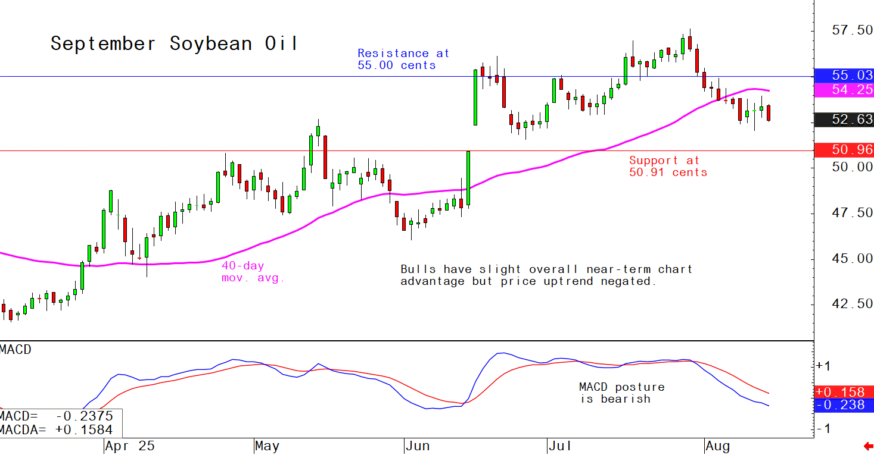

Agricultural Prices

